The POWER Project
Promoting Older Women’s Engagement in Recovery

Grantee: INSTITUTE FOR HEALTH AND RECOVERY
Grant#: ASTWH170062
Program Service Office: OASH/OWH - Central Office
Program: Women's Health
Grant Program: Advancing System Improvements for Key Issues
Reporting Period: Final Report June, 2017 - June, 2020
Agency Name: Institute for Health and Recovery, Inc.
Agency Location: Cambridge, MA.
Site Location: Cambridge, MA.
Principal Investigator: Norma Finkelstein, Ph.D.
Evaluator for the grant: Institute for Community Health.
Person writing report: Veronica Emilia Nuzzolo, Ph.D., CADC.
Completed by: Veronica Emilia Nuzzolo, Ph.D., CADC, Project Coordinator, (617) 661-3991
Date of Report: July 1, 2020.

TABLE OF CONTENTS
Contents
Project Initiation: 6
Staff: 6
Advisory Committee 7
Advisory Committee Contributions 11
Formative Evaluation 11
Proposed Goals and Objectives: 13
Outcomes: 21
Capacity Building 23
Staff – Agency Trainings 23
Opioid 101 Training 23
Trauma Informed Training 24
Elder SBIRT Training 25
Elder Motivational Interviewing: Advancing the Practice for Work with Older Adults 25
Consumer Trainings, Presentations, and Events 26
Wellness Toolbox Series 26
Gaining Power over Pain, Medications, and Opioids 27
Relaxation for Stress and Pain Management 27
Opioid Use and Misuse in Older Adults 28
Opioid Prescribing Policy Changes and the Impact on Chronic Pain Patients and Older Adults 28
Consumer Medication Take Back Nights 28
Public Information Campaign 29
Pamphlet Distribution 29
Social Media 29
Television Appearances 30
Program Implementation/Impact 30
Evaluation Report 30
Logic modeling 30
Evaluation design and data collection strategies 30
Provider Trainings 33
Process Data 33
Outcomes Data 36
Opioid Use and Misuse Trainings 36
SBIRT and Motivational Interviewing (MI) Trainings 37
Trauma and Seeking Safety Trainings 39
Training Satisfaction 40
Qualitative Findings 41
Consumer Interventions 42
Process Data 42
Outcomes Data 44
Opioid Use and Misuse 44
Medication Management 45
Alternative Approaches to Pain and Stress Management 46
Knowledge of Community Resources 47
Public Information Campaign 48
Significant Project Results: 49
Program Conclusion 49
Challenges 49
Lessons Learned 51
Successes 51
Evaluation Conclusion 52
Recommendations from Training Participants 52
Recommendations from Key Stakeholders 53
Limitations 54
Conclusion 55
Significant Developments – COVID-19 56
Change in functionality of IHR due to COVID-19 56
Appendices 57
Appendix A Goals and Objectives 57
Appendix B Outcomes 64
Appendix C Logic Model 68
Appendix D Detailed Work Plan: 69
Project Attachments - Promotional Materials 79
POWER Description 79
About IHR 80
Talk to Your Doc 81
Staying Med Compliant 82
State of Massachusetts Opioid 101 Workshops 84
Key Note Speaking Events 85
District Attorney Marian T. Ryan Opioid Task Force 87
Project Attachments – Consumer Educational Materials 88
Talk to your Doc 88
Older Adults and Alcohol 89
Safe Use of Medications 90
Exercise and Physical Activity 90
Workout to Go 92
Healthy Eating – What’s on Your Plate 93
Project Attachments – Agency/Staff Workshop Educational Materials 94
Talking to Your Patients about Opioids 94
Talking with Your Older Patients 95
Language Matters 1 96
Language Matters 2 97
DSM V Opioid Use Disorder 98
Signs and Symptoms of Potential Opioid Use 99
Commonly Used Terms 100
SBIRT Revised Screening Tool 101
Training Evaluations 103
Opioid Training Evaluation 103
Trauma Informed Training Evaluation 104
SBIRT Training Evaluation 105
Motivational Interviewing Training Evaluation 106
Opioid 101 Training Workshop – 3 Part Webinar Series 107
Change in functionality of IHR due to COVID-19 108
Email Notification 1 108
Email Notification 2 109
Email Notification 3 110
Email Notification 4 111

Program Purpose Summary
The Institute for Health and Recovery (IHR), a statewide service, research, policy and program development agency with its administrative offices in Cambridge, Massachusetts, proposed a three-year project to increase awareness of the risks of opioid use among women 55 years of age and older. Through a generous grant from the Office on Women’s Health, IHR developed the Promoting Older Women’s Engagement in Recovery (POWER) project that focused on preventing the misuse of, as well as potential for, opioid dependence among women ages 55 and older in Somerville and Cambridge Massachusetts. During the third year POWER was expanded into Malden, Massachusetts.
The POWER project used a comprehensive strategy of prevention efforts to target opioid use/misuse in older women, including trainings for service providers who work with older women, direct programming for women ages 55 and older, and a public education campaign targeted to the general public.
In collaboration with community partner agencies, IHR built on existing projects and interventions in the Cambridge, Somerville, and Malden areas to increase awareness of the potential risks and benefits of medically approved opioids in women ages 55 and older. POWER offered prevention strategies to decrease the potential for misuse by providing evidence informed activities that provided older women at partner sites with information on opioids, the delicate balance between the risks and benefits of opioid use, strategies for avoiding misuse, and appropriately managing pain medications. Activities also introduced women to grounding techniques and coping skills for stress reduction, as well as alternative pain management techniques and resources.
Older women are frequently a “hidden population” of opioid users and may be prescribed opioids for pain relief that is rooted in experiences of trauma. We offered consumers and staff agency strategies for minimizing the risk of unintentional opioid use including trauma-informed support groups for women, training for staff of primary care and elder services organizations, motivational interviewing, the appropriate use of SBIRT, and training on trauma informed care. Over the course of three years, IHR served approximately 396 women age 55 and older, providing support groups that increased knowledge of the risks and benefits of medically approved prescribed opioid medications, medication management, and unintentional opioid misuse. POWER support groups also helped increase consumer knowledge on the risks associated with elder isolation, and offered psycho-education and information regarding the links between trauma, physical and psychological pain.
The POWER project trained over 982 staff members of partner agencies to recognize signs and symptoms of opioid use/misuse, trauma informed care, elder SBIRT and motivational interviewing. POWER provided trainings and technical assistance to staff of partner agencies on a number of topics including; education on opioid use disorders and the links between opioid misuse, trauma, and chronic pain; the intersection of trauma and substance use; using the trauma group protocol Seeking Safety with older women; and implementing an Older Women's SBIRT protocol so staff could routinely screen for, recognize and intervene in opioid misuse amongst their clients. POWER also provided information on opioids and opioid misuse in older women through the dissemination of informational materials at partner sites and cable access TV appearances. These discussions were designed specifically to raise community awareness on the issue of opioid use as well as misuse in older women. POWER also participated in a state opioid task force and other networking activities.

Project Initiation:

Staff:
In the first month of funding, IHR’s Principal Investigator and Executive Director, Norma Finkelstein, Ph.D. wrote a job description for the Project Coordinator position and posted the job for internal and external candidates. Interviews were conducted in August, 2017 and a Project Coordinator was hired. Work began in early September, 2017. During the first month Dr. Finkelstein and the Project Coordinator finalized a detailed work plan for the three-year length of the project including project goals and objectives. In conjunction with the evaluation team a logic model was developed to illustrate the program’s model for change (Attachment B).
With the POWER Project Coordinator hired and with the input and assistance of Community Partners, Dr. Finkelstein and the Project Coordinator gathered and created promotional and educational materials regarding the Project that would peak the curiosity of the elder community (see Program Attachments). These promotional materials were distributed in various locations throughout the community such as; healthcare facilities, senior centers, councils on aging, and senior housing authorities.
The POWER Project Coordinator did extensive outreach in support of the project’s start-up, including meetings with representatives from The Executive Office of Elder Affairs, Senior Center Directors, Council on Aging Project Managers, Senior Housing Project Coordinators and Managers, the District Attorney’s Opioid Task Force, Home Health Care Aide Facilities, and Meals on Wheels Program Coordinators.

Advisory Committee
After receiving the notice of grant award, Dr. Finkelstein met with Directors of Partner Organizations in the local community. A list was developed of potential Advisory Committee members and letters of invitation were sent out. The first Advisory Committee meeting was held on September 29, 2017.
The established Advisory Committee was composed of representatives from partner agencies and other identified experts. The committee convened quarterly to review project activities and to provide recommendations and guidance on continued project development. The Advisory Committee helped guide and evaluate the project throughout the life of the grant.
Since creating and tailoring a program for older women ages 55 and older was both unprecedented and long overdue in Massachusetts, there were a number of stakeholders with a keen interest in the creation of the POWER Project. Representatives from state agencies and provider organizations alike through the creation of the POWER project became aware that this segment of the population comprised a unique underserved population that required programs tailored to their specific needs. Aware that this was an important opportunity for all stakeholders, the Advisory Board, initially comprised of 10 members, continuously increased members throughout the life of the grant. By year three, the Advisory Committee had 15 active members representing our local, state, and federal partners.
This Advisory Board consisted of representatives from the following community partners:
The Massachusetts Executive Office on Elder Affairs (EOEA).
The EOEA promoted community education programs, professional training and findings developed under this project to its network of 24 home care agencies and 349 councils on aging, which provided community-based long term care, healthy aging programming, caregiver support and opportunities for socialization to the 1.3 million older adults living in Massachusetts. EOEA and its partner agencies worked with IHR leadership to promote appropriate referrals to adult protective services in order to support recovery and health of older women identified by project staff as being at risk of harm due to opioid use. EOEA worked closely with IHR to assist in identifying community resources and leaders that could assist at-risk older women identified through POWER, ensuring access to the full array of services and supports that could help them remain active and productive in their communities.
The Massachusetts Bureau of Substance Addiction Services (BSAS)
BSAS agreed to work with IHR to produce, select and disseminate materials to the field. In addition, BSAS agreed to have IHR present grant findings to the BSAS team at staff meetings, conferences, and the like during the dissemination phase. BSAS continued to work with IHR to help build capacity and create change system-wide as part of the goals of this grant. As the state's primary department focused on substance use and addiction, BSAS offered a multitude of knowledge on the mechanics of addiction, opioid addiction, and the issues fueling the current opioid epidemic. The insight and expertise of BSAS was instrumental in the information and trainings created as part of POWER. BSAS also created many informational resources on substance use and elders that will be disseminated to identified partner agency sites as part of the project's public information campaign.
MASBIRT Training and Technical Assistance (TTA).
MASBIRT is currently funded by the Massachusetts Department of Public Health Bureau of Substance Addiction Services to provide SBIRT training and technical assistance to aid in the uptake and dissemination of Screening, Brief Intervention, and Referral to Treatment (SBIRT) services in healthcare and public health settings around the state. MASBIRT TTA collaborated with IHR to train SBIRT concepts and to develop an Elder SBIRT curriculum for this grant specific to the target population. MASBIRT TTA worked closely with IHR throughout the implementation of the project to offer training and updates to IHR staff who were providing Elder SBIRT training.
Cambridge Health Alliance (CHA).
CHA is a large health care system consisting of 3 hospitals and 15 health centers. CHA is a public hospital in the state of Massachusetts and is a safety net hospital. CHA is committed to providing health services to the diverse population of the Commonwealth and are experienced with the cultural and social determinants that may impact access to prevention and treatment, especially for this population of older women. As a partner in this grant, CHA agreed to allow IHR to post and distribute prevention and informational materials at CHA’s sites for elders and present any findings of the grant to the CHA team during the dissemination phase. CHA also has a geriatrics department with multiple programs who became active participants in this project - in particular the House Calls program and the Elder Service Plan. Both of these geriatric programs were involved in staff trainings that were offered as part of our project.
The Cambridge Council on Aging (CCOA).
The CCOA agreed to share referrals with IHR as needed, allow IHR to post and distribute prevention and information materials at CCOA's sites for elders and present any findings of the grant to CCOA team during the dissemination phase. CCOA worked with IHR to arrange space and capacity for support groups of older women at the Cambridge Senior Center. CCOA serves approximately 900 women per year through senior centers and other activities, including support groups, regular programs on preventing injury, and a variety of social services. A high percentage of the women served are Latina, Haitian, and Chinese. They operate two senior centers in the city of Cambridge that offer a variety of programming including exercise classes, health and wellness course and presentations, support groups, and a food pantry and daily lunch program.
The Somerville Council on Aging (SCOA).
SCOA agreed to share referrals with IHR as needed, allowed IHR to post and distribute prevention and information materials at SCOA's sites for elders and present any findings of the grant to SCOA team during the dissemination phase. SCOA also worked with IHR to arrange space and capacity for support groups of older women at the Somerville Senior Centers. The Somerville Council on Aging supports older adults in their efforts to maintain their independence by enhancing growth, dignity, and a sense of belonging in mind, body, and spirit while they age in place. The SCOA takes full responsibility to provide access to fitness, health, and wellness activities, socialization opportunities, educational programs, transportation, and support services. The SCOA is committed to promoting and protecting health services for the diverse population of the City of Somerville Massachusetts, and is experienced with the cultural and social determinants that may impact access to substance use and mental health treatment, especially for this population of older women.
The Somerville Cambridge Elder Services (SCES).
The SCES agreed to share referrals with IHR as needed, and also allow IHR to post and distribute prevention and informational materials at the SCES' sites for elders and present any findings of the grant to SCES team during the dissemination phase. Since 1972, Somerville-Cambridge Elder Services (SCES) has been the area’s aging information and service center. SCES services are available to older residents of Cambridge and Somerville, as well as their caregivers. SCES helps older people and people living with disabilities remain safe and independent in their own homes by providing a wide range of supportive services, as well as information and advice. SCES is a state-designated Aging Services Access Point (ASAP), formerly known as a Home Care Corporation (HCC), and a federally-designated Area Agency on Aging (AAA). SCES is also the designated Elder Protective Service Agency for the cities of Cambridge and Somerville. Along with serving over 2,000 seniors a year through their multitude of community based and home based services, SCES brings with them a knowledgeable staff, passionate about serving the aging population of our community. The staff of SCES were engaged and eager to learn more interventions to promote the health of their clients, and brought a wealth of knowledge to support this project.
Institute for Community Health – (ICH).
ICH was contracted as evaluator on the POWER project. ICH has a history of using thorough and collaborative approaches in researching the causes and effects of public health issues, especially within hidden communities. ICH had a unique opportunity to lend their expertise to this grant as their location and strong relationship with CHA provided valuable access to the proposed target locations. As a sub-recipient, ICH acted as the evaluator during this three-year grant, and created a needs assessment and established a baseline of knowledge for providers. ICH was responsible for providing information and research on the impact of the work done through this grant. ICH contracted with this grant for $15,000 a year, for three years.

Advisory Committee Contributions
Throughout all three years of the POWER project, the Committee made recommendations on project programming including the ongoing development and implementation of a gender specific screening tool for SBIRT (see Project Attachments) that is adapted to address prescription opioid medication misuse in older women. The Advisory Committee played a vital role in helping POWER staff trouble shoot identified obstacles including revision of the psycho-educational support group “Wellness in Aging.” With the help of evaluation data and analysis from year one pilot activities, POWER identified areas of concern at Advisory Committee meetings for discussion and revision. POWER utilized the varied expertise of the committee and insight provided regarding high quality information accessible to the target age group. Advisory Committee members were also asked to provide insight on recruitment, retention, and sustainability methods for engaging both staff at partner agencies and the women we hoped to serve.

Formative Evaluation
In November of 2017, the Institute for Community Health (ICH), in partnership with the Institute for Health and Recovery, (IHR) conducted a formative evaluation to help guide the development and implementation of the POWER program. Information from the focus group was summarized and used to inform future POWER programming for women. This evaluation included five key informant interviews with experts in the health of older women with substance use disorder and a focus group with women aged 55 and older.
The interviews were designed to inform program planners about 1) key needs and issues affecting women aged 55 and older in the Cambridge/Somerville area, 2) how women aged 55 and older access information relating to substance use and substance use disorder (SUD), and 3) the needs of providers and staff of elder service agencies in working with this population. Key informants came from a variety of organizations in the Cambridge/Somerville area that serve older women and had worked with older women for several years. In a summary of interview data, the need to address social isolation among women aged 55 and older through increased opportunities for socialization was a strong theme. A second strong theme was a need for improved coordination and communication around the medical care that older women receive. Women who already have SUD in particular would benefit from support groups and support in talking to their doctor about issues and concerns around opioids. Key informants identified several priorities for education for women over age 55 including:
- The risks and benefits of opioids
- Medication management (use, tracking, secure storage and disposal)
- Assessing risk of opioid misuse in self and others (including warning signs of nonmedical opioid use) and strategies for addressing concerns
- The link between trauma/psychological pain, chronic physical pain, and SUD
The focus group was intended to help program planners better understand the needs of and problems facing women age 55 and older, specifically relating to opioids, stress, and pain from the perspective of older women themselves. Three clients of the Cambridge Senior Center participated in the focus group. Participants in the focus group expressed a need for more information about opioids and concerns about medication management and over prescribing. Participants emphasized they had concerns about addiction and managing chronic pain and stress. The information shared by key informants and focus group participants overlapped on a number of key points suggesting some areas in which POWER could be most beneficial. Both key informants and focus group participants suggested that alternative methods of pain and stress management, such as yoga or mindfulness, would be a welcome benefit for women 55 and older. This information, in combination with feedback from meetings with key stakeholders, helped to inform the development of goals, objectives and expected outcomes for the POWER initiative.

Proposed Goals and Objectives:
Over the course of three years, IHR set forth to serve at least 90 women age 60 to 80, providing support groups that decrease isolation and offer psycho-education and information about the links between trauma, physical and psychological pain, and opioid use. IHR also proposed to train staff of partner agencies in recognizing opioid use and misuse, a trauma informed training designed to address the effects of trauma and links between trauma and substance use, Elder SBIRT to increase the ability to screen and make referrals for treatment as needed. To achieve these objectives, proposed outcomes for the three year grant included:
- Increase older women’s awareness of effects of opioids and links between chronic pain and trauma or psychological distress
- Increase older women’s sense of agency in addressing opiate-related issues for themselves and loved ones
- Increase understanding among providers and care managers of underlying psychosocial factors and their relation to rates of misuse of opioid medications
- In partnership with OWH, widely disseminate project results and tools used
To achieve these outcomes the following 4 goals were set:
- Goal 1: Among 30 women ages 55+ in Somerville and Cambridge, increase the knowledge and understanding of the potential risks and benefits of opioids, and increase the self-reported ability of these same women to identify and manage risks of opioid use, misuse, and/or addiction in themselves and others.
- Goal 2: Among at least 30 women ages 55+ in Somerville and Cambridge, increase awareness of the prevalence and causes of trauma/psychological pain in older women, the link between psychological pain and chronic physical pain, and provide them with coping mechanisms and tools to address their own trauma and/or psychological pain.
- Goal 3: Among women ages 55+ in Somerville and Cambridge, increase understanding of and access to alternative methods of chronic physical pain management, such as physical therapy and acupuncture, while also teaching simple pain management skills to use on their own.
- Goal 4: Increase the knowledge and skills of at least 50 service providers at partner agencies about substance use and opioid misuse in older women, the links between older women’s histories of trauma/psychological distress and use of opiates for relief, and screening tools and treatment options specifically geared towards older women.
At the start of Year-3 the goals and objectives were revised to better align with current programming and to align with the Goals and Objectives written into the Year 3 OWHPA Award (Appendix D) as detailed in the chart below:
Goal 1: Among 30 women ages 55+ in Somerville and Cambridge increase the knowledge and understanding of the potential risks and benefits of opioids, increase the self-reported ability to identify and manage risks of opioid use, misuse, and/or active disease in themselves and others. *
* In Year 3, the service area was expanded to include Malden and the target number of women to engage was increased to 45. Also in Year 3, the following text was added: Increase understanding of stress management, pain management alternatives, and physical therapy and coping skills.

Objective 1.1 | Distribute 100 informational brochures and flyers on prescription opioid misuse and pain in older women to 4 community sites (increasing to a total of 10 community sites over the three-year period) that regularly serve women in Cambridge, Somerville. *  *Malden was added to the service area in Year 3.
Objective 1.2 | Make at least 2 appearances on local cable access TV shows annually to discuss the intricacies of opioid use in older women, including the dangers, particularly in relation to older women. *  *In Year 3 italicized text was changed to “the relationship to pain, pain management and/or trauma.”
Objective 1.3* | Through at least two supportive groups annually held at partner agency sites, reach out to and engage a minimum of 15 women, ages 55+ to provide information on the risks and benefits of opioids as well as strategies and skills for addressing concerns around this topic such as tips for medication management and storage, skills to facilitate active collaboration with prescribing doctors, tools to identify risk factors and referrals.  *In Year 3 italicized text was changed to “providing strategies and skills for addressing stress and pain to prevent the initiation of opioids or the misuse of opioid medication already prescribed.”
Objective 1.4 | Through educational presentations held at partner agency sites in Cambridge and Somerville, engage a minimum of another 15 women ages 55+ to provide information on the risks and benefits of opioids as well as providing strategies for assessing risk in self and others, and tips in how to minimize risks.  * In Year 2 italicized text was changed to “and other creative participation strategies”  Y3: Objective 1.4 was changed to “Educate women on stress, the impact of stress and the connection between pain and stress, and non-pharmacological options for pain management.”
Goal 2 (Y1 &2): Among at least 30 women ages 55+ in Somerville and Cambridge, increase the awareness of the prevalence and causes of trauma/psychological pain in older women, the link between psychological pain and chronic physical pain, and provide them with coping mechanisms and tools to address their own trauma and/or psychological pain.
Objective 2.1 | Through two groups held at partner sites, educate at least the same 15 women ages 15+ on the connection between trauma, emotional pain and physical pain.
Objective 2.2 | In supportive groups, offer these same 15 women psycho-education and skill building interventions to manage psychological pain, including some elements of the intervention Seeking Safety that will specifically teach grounding and coping skills.  * In Y2 Italicized text was changed to “and stress, such as deep breathing skills, relaxation, and mindfulness skills.
Objective 2.3 (Y1 only) | Use Cognitive Behavioral techniques, including mindfulness skills, with these same 15 women to assist them in managing and reducing stress.
Objective 2.4 | Through educational presentations* held at partner agency sites in Cambridge and Somerville, engage a minimum of 15 additional women 55+ to provide information on the prevalence of trauma, common causes of trauma in older women, and the connection between psychological pain and physical pain. **  * “and other creative participation strategies” added in Y2.  **The following text added in Y2: “Explore the possibility of offering group treatment Seeking Safety at certain partner sites to women 55+ struggling with opioid misuse and trauma.”
Goal 2 (Y3): Increase the knowledge of at least 50 service providers at partner agencies about opioid use, misuse, and active disease. Increase the knowledge of risk factors and potential benefits of opiates for relief, and increase understanding of and access to medication assisted treatment, treatment options specifically geared towards older women.
Objective 2.1 | Provide training to at least 30 new staff at partner agencies and local community sites on the use of opioids in older women and their high risk for abuse. This training will include information on risks and benefits, warning signs of misuse, and referral information.
Objective 2.2 | Provide all staff trained in any of the above interventions with information on community based substance use disorder and mental health treatment and resources, including Medication Assisted Treatment if needed, and provide instruction on making referrals.
Objective 2.3 | Continue building relationships with the potential new partners identified in Years 1 and 2 (at least the five other healthcare and community service providers in Cambridge, Somerville and Malden serving women 55+; including hospitals, city housing authorities, and women’s shelters), in order to offer trainings and resources around substance use, opioid misuse, and trauma in older women.
Objective 2.4 | In collaboration with partner agency staff, integrate information about opioid use, misuse and active disease into existing programming at partner agencies to increase the knowledge of opioid risks and benefits, pain management resources and treatment strategies in women ages 55+.
Goal 3 (Y1&2): Among women ages 55+ in Somerville and Cambridge, increase understanding of and access to alternative methods of chronic physical pain management, such as physical therapy and acupuncture, while also teaching simple pain management skills to use on their own.
Objective 3.1 | In collaboration with partner agency staff, integrate information about alternative pain management options into existing programming at partner agencies to increase the knowledge of other pain management resources and strategies in women ages 55+.
Objective 3.2 | Through the same groups offered to 30* women per year, and through integration into pre-existing programming at partner agency sites, teach basic mindfulness techniques to older women and provide information about mindfulness related workshops and activities within the community.  *15 women in Y2
Goal 4*: Increase the knowledge of at least 20 service providers at partner agencies about substance/opioid use and misuse, and the correlation between trauma/psychological distress and use of opiates and relief, and screening tools and treatment options specifically geared towards older women.
*Goal 3 in Y3, with a goal of serving at least 50 providers, and the italicized text omitted.
Objective 4.1 (3.1 in Y3) | Y1: Provide at least 40 staff members at Somerville Cambridge Elder Services (SCES), Cambridge Council on Aging (CCOA), and Somerville Council on Aging (SCOA) with basic training on substance use disorders, addiction, and the links between substance use and trauma, particularly in older women.  Y2: Provide at least 40 staff members at partner agency sites, including Somerville Cambridge Elder Services and Cambridge Health Alliance, with Part 2 Elder SBIRT trainings (following up on the introduction trainings done at these sites in year 1), with a focus on motivational interviewing and effectively using the brief negotiated interview (BNI) algorithm to discuss substance use issues, and particularly opioid misuse, with older women clients.  Y3: Train at least 10 more social work and clinical staff at partner agency sites on issues of trauma, substance use and older adults, including the possibility for trainings on Trauma Informed Care.
Objective 4.2 (Y1&2) | Y1: Provide these same staff with education around opiates and their high risk for abuse, particularly in older women.  Y2: Provide training to at least 30 new staff at partner agencies and local community sites on the use of opioids in older women and their high risk for abuse. This training will include information on risks and benefits, warning signs of misuse, and referral information
Objective 4.3 (Y1&2) | Train 30 staff from partner agencies and new community partners in Elder SBIRT with several follow up training sessions to strengthen learning and effective use of the tool, using in kind support from IHR and BSAS staff specializing in SBIRT.
Objective 4.4 (Y1&2) | Y1: Train 10 social work and clinical staff from SCES and CHA Geriatrics Department in the Seeking Safety interventions for individual use, including adaptations IHR has been involved with in the past to enhance this intervention for older women.  Y2: Train at least 10 more social work and clinical staff (additional from year 1) at partner agency sites on issues of trauma, substance use, and older adults, including the possibility for trainings on using Seeking Safety with Older Adults.
Objective 4.5 (Y1&2) | Provide all staff trained in any of the above interventions with information on community based substance use disorder and mental health treatment and resources, including Medication Assisted Treatment if needed, and provide instruction on making referrals.
Objective 4.6 (Y1&2) | Y1: Continue to build relationships with at least five other healthcare and community service providers in Cambridge and Somerville serving women 55+ (including hospitals, city housing authorities, and women’s shelters) in the first year to collect information about their training and service needs in regard to substance use and opioids in women 55+, and work to meet those needs in years two and three.  Y2: Continue building relationships with the potential new partners identified in Year 1, (at least the five other healthcare and  community service providers in Cambridge and Somerville serving women 55+; including hospitals, city housing authorities, and women’s  shelters), in order to offer trainings and resources around substance use, opioid misuse, and trauma in older women
Goal 4 (Y3): Increase the knowledge and skills of at least 20 service providers at partner agencies about screening tools and treatment options Screening Brief Intervention Referral to Treatment (SBIRT) and Motivational Interviewing (MI) techniques.
Objective 4.1 (Y3) | Train at least 20 new staff, from both current partner agencies and potential new community partners, in Elder SBIRT for older women with several follow up training sessions to strengthen learning and effective use of the tool, using in kind support from IHR and BSAS staff specializing in SBIRT.
Objective 4.2 (Y3) | Provide at least 20 staff members at partner agency sites, including Somerville and Cambridge Elder Services and Cambridge Health Alliance, with Part 2 Elder SBIRT trainings (following up on the introduction trainings done at these sites in years 1 and 2), with a focus on motivational interviewing and effectively using the brief negotiated interview (BNI) algorithm to discuss substance use issues, and particularly opioid misuse, with older women clients.
Goal 5: Increase understanding among professionals*, health care and community service providers about feasible and effective interventions for addressing opiate use in women ages 55+.
* “including the Advisory Committee” added in Y3
Objective 5.1 | Y1: Engage in an exploratory information gathering process through work with community partners, the creation of the project’s advisory committee, and a formative evaluation process using key informant interviews and a focus group, all of which will serve the purpose of raising consciousness and building a foundational understanding about the relatively unknown and underserved issues related to opioid misuse and substance use disorders in older women in Cambridge and Somerville.  Y2 & 3: Continue holding quarterly Advisory Committee meetings for this project to both update on accomplished activities and to get feedback and advice on future project activities. Issues, concerns, and insights through these meetings will be documented into the evaluation process and a final report on the findings of this project and the lessons learned.
Objective 5.2 | Conduct process and outcome evaluations on each component of the intervention, using lessons learned to refine successive iterations of interventions and activities over the 3 years of the project.
Objective 5.3 | Share information about substance use, and in particular opioids, in women 55+ with the Somerville/Cambridge community and disseminate relevant information and findings to professional and community audiences including through social media and an email listserv, community forums, and at professional conferences as opportunities arise.

Outcomes:
1 | At least 100 informational brochures and flyers will be distributed to 4 community sites in year 1, and 100 informational brochures and flyers in year 2.
2 | At least 2 appearances will be made on local cable access TV shows in year 1, and 2 appearances in year 2.
3 | CONSUMERS - 70% of women ages 55+ served through this project will increase their knowledge and awareness of opioids, particularly those that are prescribed, and their appropriate use including potential risks and benefits
4 | CONSUMERS - 70% of women ages 55+ served through this project will increase their knowledge and awareness of the warning signs of opioid misuse in themselves and others.
5 | CONSUMERS - 70% of women ages 55+ served through this project will increase their self-reported ability to address medication concerns with providers and manage medications appropriately
6 | CONSUMERS - 70% of women ages 55+ served through this project will increase their knowledge and awareness of alternative methods to manage chronic pain.
7 | CONSUMERS - 70% of women ages 55+ served through this project will increase their knowledge and awareness of available community resources for older women for addressing both psychological and physical pain, and substance use issues.
8 | CONSUMERS - 70% of women ages 55+ served through this project will increase their intention to utilize alternative pain management strategies.
9 | OPIOID TRAINING - 80% of staff at partner agencies trained through this project will increase their level of knowledge on substance use and addiction in older women, particularly with a focus on opioids and their potential consequences and benefits.
10 | OPIOID TRAINING - 80% of staff at partner agencies trained through this project will increase their level of knowledge of the warning signs of opioid misuse
11 | OPIOID TRAINING - 80% of staff at partner agencies trained through this project will increase their level of knowledge of community services that can help address psychological and chronic physical pain for older women, and substance use disorders.
12 | OPIOID TRAINING - 70% of staff at partner agencies trained through this project will report increased ability to assess risk factors in older women for opioid misuse.
13 | OPIOID TRAINING - 80% of Staff members will integrate information presented on opioid use, misuse, and active disease, warning signs and risk factors into their future practice with older adults.
14 | TRAUMA INFORMED TRAINING - 70% of staff at partner agencies trained through this project will be better able to understand the role of trauma in their clients’ life.
15 | SBIRT/MI TRAINING - 50% of staff at partner agencies trained through this project will report increased ability to implement Elder SBIRT using MI techniques.
16 | SBIRT/MI TRAINING - 70% of staff at partner agencies trained through this project on SBIRT/MI will be better able to refer women to appropriate levels of treatment including inpatient/outpatient treatment and services as needed.
17 | The project coordinator will reach out to at least five other healthcare or community services organizations serving women 55+ in Cambridge and Somerville in order to build relationships and discuss potential opportunities for project collaboration or information sharing.
18 | Partner Agencies will continue to integrate information presented through the POWER PROJECT regarding opioid use, misuse, and active disease in older women, into partner agencies existing programming after the life of this grant.
19 | Quarterly, project staff will generate a brief summary and analysis of process and outcome evaluation data that will inform future work and will be distributed to the Advisory Committee and other key actors.

Capacity Building
Outreach
The following strategies and interventions were conducted during the life of this grant:
The POWER Project conducted outreach throughout the Cambridge and Somerville communities to cultivate the project’s relationship within the community and to make connections with agencies in neighboring communities that serve the elder population. Through this networking, the Project Coordinator successfully created a new network of elder service providers, including new affiliates in the neighboring cities of Malden and Winchester, Massachusetts.
The POWER Project conducted community capacity building to prevent opioid misuse among older women by presenting information at and attending community meetings, partner organization meetings, and building connections with community organizations and leaders in the Cambridge, Somerville, and Malden communities. These efforts were assessed quantitatively through process data on community meetings and attendance at other events (see Appendix B).

Staff – Agency Trainings

Opioid 101 Training
This training was developed to increase and build upon staff's ability to engage in discussions regarding substance use and misuse with clients who were exhibiting risky behaviors for the sake of both primary and secondary prevention efforts (see project attachments). Focus was given to what to do in circumstances where misuse was suspected. Group training discussion was geared towards opioid misuse and how opioid use disorder presents itself in older adults in general; specific discussion focused on how opioids affect older women in particular. This workshop was designed to improve staff's knowledge on recognizing risks, signs, and symptoms of potential opioid use, misuse or dependency. The primary goal of these workshops was to provide all staff with a sense of how the opioid crisis affects the seniors they work with and provide them with resources if they have concerns. The workshop reviewed current literature and research on opioid misuse in older adults with a specific focus on older women. Participants received an overview of opioids and learned how to recognize changes in behavioral patterns, potential signs and symptoms associated with opioid/substance use disorder. Discussion included age and gender specific contexts for opioid misuse, the balance between the risks and benefits of opioids for chronic pain management, and potential prevention interventions.
Training Objectives:
1. To define opioid/substance use, misuse, and dependence
2. Risk factors related to opioid/substance use/misuse, safety and management tips to avoid misuse
3. The potential consequences associated with opioid/substance use/misuse
4. Traditional and contemporary drugs of choice
5. Local efforts in Cambridge and Somerville to address opioid misuse in older women

Trauma Informed Training
This training was designed for people who worked with older adults. The training described different pathways the impact of trauma may be encountered among older adults and how the impact of trauma can negatively affect quality of life. The overlap between trauma and substance use were also discussed. Specific issues to consider when working with older adults affected by trauma and substance use was discussed, as well as what is known about treating the impact of trauma and substance use in older adults. The training assists healthcare workers to recognize the impact of trauma in the older adults they encounter. It also helps them identify the connection between trauma and unsafe coping, including substance use.
Training Objectives:
1. Participants will be able to list the different pathways by which the impact of trauma may be encountered among older adults
2. Participants will be able to describe the ways the impact of trauma can negatively affect the life experience of older adults
3. Participants will be able to list specific issues to consider when working with older adults affected by trauma
4. Participants will be able to describe what is known about treating the impact of trauma in older adults

Elder SBIRT Training
This training presentation focused on providing an overview of SBIRT. This SBIRT training assisted participants in increasing their ability to effectively use SBIRT in their work with clients to assess and identify appropriate levels of treatment, treatment options, and treatment referrals. Screening, Brief Intervention and Referral to Treatment (SBIRT) is a comprehensive, integrated, public health approach for early identification and intervention with patients whose patterns of alcohol and/or drug use put their health at risk. Practitioners learned the three major components of SBIRT that can be integrated into counseling in healthcare work setting.
Training Objectives:
1. Universal, annual Screening (S) identifies unhealthy use. 75-85% of patients will screen negative. For those who screen positive, further assessment is needed to determine level of risk,
2. Brief Intervention (BI) provides feedback about unhealthy substance use. It also focuses on education, increasing patient insight and awareness about risks related to unhealthy substance use, and enhances motivation toward healthy behavioral change.
3. Referral to Treatment (RT) helps facilitate access to addiction assessment and treatment.

Elder Motivational Interviewing: Advancing the Practice for Work with Older Adults
This training focused on the foundational skills of motivational interviewing (MI). It began with a review of the purpose of MI including the spirit of MI, the use of ambivalence, and how MI is about evoking change talk to move towards behavioral change. The training then reviewed the basic engagement skills of MI - OARS (Open Ended Questions, Affirmations, Reflective Listening, and Summarizing). We provided opportunities for practice with partners on some of these skills. We primarily focused on reflective listening and using complex reflective statements to show understanding and active listening. The training then introduced the Brief Negotiated Interview (BNI) which is a guided script used for Brief Interventions in SBIRT to engage a client about a behavioral change. The BNI uses the foundational skills of MI as its format for engagement. The training reviewed the different sections of the BNI and explained their purposes. We then provided a role play example of using the BNI and gave the participants time to practice the BNI in pairs. We discussed areas that were difficult and the training culminated in a discussion of the need for practice and continued training for the MI skills to solidify.
The training contained didactic and experiential components for deepening skills. MI is a foundational skill for SBIRT so that staff were prepared for eventual implementation of a screening and brief intervention process.

Consumer Trainings, Presentations, and Events
The first activities of the POWER initiative were designed for local community consumers. Coffee Hours and Informational Groups were conducted. Discussion at these events included topics such as medication management, stress and wellness, and pain management. Other activities included yoga classes, relaxation techniques, and pain management alternatives.

Wellness Toolbox Series
IHR developed the Wellness Toolbox curriculum and facilitated sessions for women in the local area beginning in the first year of the initiative. The series was revised and retitled “Prescription Opioids: Safety, Risks, and Why This Matters as We Get Older” in year three. These one hour presentations for consumers were held at the Cambridge Senior Center, The Somerville Council on Aging, and multiple Senior Housing complexes. The purpose of these consumer presentations/trainings was to provide basic information about prescription opioids to older women. The presentations provided information on the names of common opioid brands, the purposes of these medications, the benefits they have if taken correctly, and also the negative effects they can have both from side effects and from misuse, whether intentional or not. Subject matter discussed included:
- Rate of opioid misuse in older adults and older women
- Definition of opioid misuse
- Consequences of opioid misuse
- Risk factors for opioid misuse in older adults
- Warnings on the dangers of using opioids with alcohol and other prescription medications
- Other Safety tips including safe storage and disposal
- How else opioid misuse affects older women (ex. elder abuse, grandparents raising grandchildren)
- Getting help and treatment for potential opioid misuse or opioid use disorder (information on local resources and services was provided)

Gaining Power over Pain, Medications, and Opioids
This presentation was half didactic and half facilitated discussion about opioids, with a heavy focus on prescription opioids and prescription opioid misuse. The presentation included an overview of what opioids are and why they might be prescribed along with a brief discussion about illicit forms of opioids, particularly heroin and fentanyl. We discussed how older adults generally come in contact with opioids, and why opioids have both benefits but also risks for older adults. In particular we talked about what some of the risks and negative consequences of opioid misuse, whether unintentional or intentional, might be in older adults. We then moved into a discussion about what increases risk for opioid misuse and related adverse effects, including the use of alcohol in combination with opioids, one’s hereditary predisposition, and social isolation/depression. The presentation reviewed potential warning signs of misuse and then discussed how to get help and the options for treatment and recovery. This presentation’s focus was often steered by the interests and knowledge base of participants. This presentation was open to both men and women, though the content was geared more towards the risk factors of opioid misuse in older women.

Relaxation for Stress and Pain Management
This consumer training used a discussion based model to engage consumers about how stress and pain affect their lives. The presenter asked participants to discuss some way they manage stress and pain, and made sure to highlight that medication, in particular prescription opioids, can be used for moderate to severe pain, but that there are other alternatives to pain management. The training included a brief discussion of how pain and stress are interconnected and the mind-body relationship. This training introduced consumers to the concepts of relaxation and deep breathing as another tool to manage stress and pain. The training concluded with an experimental exercise where the trainer led the consumers in a deep breathing and relaxation exercise, often time using guided imagery as well.

Opioid Use and Misuse in Older Adults
This training was focused on providing an overview to consumers on what opioids are and how they effect older adults, with a particular focus on older women. The training began with a basic education of what opioids are (both prescription and illicit) and common names of prescription opioids. We briefly reviewed the current opioid epidemic and dovetail to where older adults fit into the current issue. The use and misuse of opioids in older adults was then discussed, including rates of prescriptions, rates of misuse, and the connection to chronic pain. Gender specific data and that related to older women’s vulnerability was highlighted. The training then discussed risk factors for misuse, potential warning signs of misuse, and harmful consequences of both deliberate and unintentional opioid misuse. The training closed with a review of what to do should you suspect someone of misusing opioids, including a review of local treatment options and prevention strategies for older women.

Opioid Prescribing Policy Changes and the Impact on Chronic Pain Patients and Older Adults
The purpose of these consumer presentations was to provide basic information about prescription opioids and the impact that policy changes were having on the older population. The presentation provided information on how to talk to your doctor regarding medication management and the safe “tapering” of prescribed medications. In addition, discussion consisted of the purposes of starting/stopping prescribed medications, the benefits medications have if taken correctly, and also the negative effects of rapid tapers from prescription medications.

Consumer Medication Take Back Nights
This event was a collaboration between the Cambridge Public Health Department, The Cambridge Police Department, The Cambridge Council on Aging, and The POWER Project. This event was a Senior Prescription Drug Take Back night. Representatives from the Cambridge Police Department and the Cambridge Public Health Department were available to accept unused or unwanted prescription drugs for proper disposal. The POWER Project Coordinator gave a medication management presentation that provided basic information on prescription drugs, managing expired medications, and the importance of proper medication disposal.

Public Information Campaign
POWER increased community-level knowledge and awareness of opioids among older women through a public awareness information campaign. The purpose of this campaign was to disseminate information on the risks and benefits of opioids to both older women and to the general public. By providing information to the general public we hoped to confront stigma around substance use in older adults while providing valuable information to younger and middle age adults who may have older women in their lives.

Pamphlet Distribution
The POWER staff identified several pamphlets and publications to use for both wide spread as well as targeted distribution. These included publications from the MA Bureau of Substance Addiction Services, the Cambridge Chapter of the Overdose Prevention and Education Network, the Substance Abuse and Mental Health Services Administration, and the National Institute on Drug Abuse. During the life of the grant, we identified primary care clinics and waiting rooms where we could distribute literature to consumers especially at our partners at CHA. We also worked with the Councils on Aging and the Somerville Cambridge Elder Services to identify locations at their sites for handouts. An Opioid 101 Workshop presentation and packet (See Project Attachments) was developed so that materials regarding the risks and benefits of medically approved prescribed opioids, recognizing signs and symptoms of potential opioid use/misuse would be distributed to providers during trainings and stakeholder meetings. In addition, we distributed business cards for the MA Helpline, a service of the Massachusetts Department of Public Health that connects people to substance use treatment services.

Social Media
POWER used IHR’s Facebook, Pinterest, and Twitter platforms to post relevant information on opioids, substance use in older adults, chronic pain, and trauma. These posts consisted of a combination of sharing articles and videos from media sources as well as sharing our own work including workshops, presentations, and TV appearances in addition to other materials created for POWER.

Television Appearances
Another way that POWER promoted the Project and disseminated informational materials was television appearances. The project coordinator worked with the hosts of two cable T.V. shows and partnered with them during the life of the project. One of these shows appears on Somerville Cable Access TV and the other appears on the Cambridge Cable Access station. Both shows also have YouTube sites where recordings of the show were posted. POWER also shared the links to these YouTube channels through social media and email to spread visibility. We also continued to explore other options for broadcasting, including zoom meetings and other programming options on these cable access channels and public service announcement media.

Program Implementation/Impact

Evaluation Report

Logic modeling
The Institute for Community Health (ICH) was the external evaluator for this initiative. The evaluation process began with meetings with IHR staff in 2017 with collaborative development of a program logic model (Appendix C). The logic model articulated the connections between program activities, expected outcomes, and ultimate impact. The purpose of the logic modeling process was to facilitate a common understanding among the evaluation team and key project stakeholders about the expected program outcomes as a precursor to developing interventions and data collection tools.

Evaluation design and data collection strategies
The evaluation was designed to assess outcomes included in the logic model, with focus on increases in knowledge, skills, and confidence for women aged 55+ and providers and staff of elder service organizations and greater public awareness for issues related to opioid use and misuse for women aged 55+. ICH utilized a mixed methods approach, incorporating both quantitative and qualitative data collection strategies. An overview of data sources is presented below.
Implementation of the public information campaign was assessed through a process level evaluation. A tracking system was developed by ICH using Google Sheets and shared with program staff to document activities conducted as part of this campaign including the number of television appearances; social media activity; participation in task forces and networking events; distribution of educational materials; and other capacity building activities. The project coordinator entered all process level data into the tracking system. The number of sites served and number and type of materials delivered to each site was reported to the OWH and the Advisory Committee on a quarterly basis.
The primary methodology for evaluating the impact of interventions for older women was a post session evaluation completed by participants of each group. ICH worked with POWER staff to create an evaluation that measured expected outcomes associated with each activity. This evaluation tool received OMB approval at the end of year one and was used as the primary methodology for evaluation purposes through subsequent project years.
The evaluation design asked participants to assess changes in their knowledge of or comfort with a given topic as a result of their participation in the intervention. Topics included knowledge in areas related to opioid use, stress, pain, and medication management, and alternative options for pain management. The evaluation surveys also asked about participants’ comfort with and intent to engage in certain activities such as using stress relief exercises and being able to manage their own medications. All questions on the evaluations related to group curriculum content. Participants were asked to complete these brief surveys following each session. Participants were informed both verbally and in writing that the survey was voluntary and confidential. No identifying information was included on the survey itself. Surveys for each training type consisted of nine-eleven multiple choice items, three dichotomous items, and two open-ended items. All data was recorded on paper surveys and then entered into the online survey platform REDCap (maintained jointly by ICH and IHR) for storage and analysis (see project attachments training evaluations).
Process level data was also collected on participation in programs offered to consumers using the tracking system used to track the public information campaign activities. Data tracked for consumer programs included participation in wellness toolbox sessions, presentation and other in person interventions geared towards engaging women, including presentations, health fairs, and coffee hour discussions.
Staff Trainings and Capacity Building were evaluated using surveys following the same approach used to evaluate consumer sessions. In collaboration with the project coordinator, ICH developed evaluation surveys for each training type to collect quantitative and qualitative data on outcomes. These surveys all received appropriate OMB clearance in year one. Surveys consisted of one or two multi-part, multiple choice items, two dichotomous items, and one open-ended item. Respondents were also asked to select their role from a menu of options. Training participants were sent an electronic follow-up survey at 3 and 6 months following their training date. These brief surveys assessed participants’ use of material from the training and integration of the training material into their professional practice. Process level data was also collected on participation in programs offered to consumers using the tracking system. Data tracked for provider and staff programs included participation in all training sessions (see project attachments training evaluations).
Quantitative survey data from multiple choice items were analyzed across all trainings and summarized quarterly. Qualitative data from the open-ended items were analyzed for overarching themes. A quarterly summary of process data, quantitative and qualitative data was shared with program staff and Advisory Committee members to inform programming and quality improvement.
ICH also collected qualitative data from key informants towards the end of the grant period. This included group interviews with representatives of the Advisory Committee and other community partners, and a survey administered to key informants who were unable to join the group interviews. The purpose of the qualitative data collection was to understand what worked well about the program, what was challenging, the impact of the program on elder service providers and consumers, and recommendations for future work. Group interviews were lightly transcribed, and transcripts were analyzed in order to identify key themes. Three key stakeholders participated in group interviews and four completed surveys.
Findings from all data sources are summarized in this evaluation report. A summary of participation in each type of activity followed by findings about program impact are presented for each program component. In the charts that follow, survey questions from staff and provider trainings were organized into four focus areas: 1) Opioid Use and Misuse, 2) SBIRT and Motivational Interviewing, 3) Trauma informed care, and 4) Satisfaction with Training. Questions from consumer workshops and presentations were organized into: 1) Opioid use and misuse; 2) Medications management; 3) Alternative approaches to pain and stress management; and 4) Knowledge of community resources. It is important to note that these findings are reflective of the people who chose to take the survey and may not be representative of the full group of providers and staff and consumers who participated in POWER programming. The report ends with a discussion of limitations and overall conclusions. See appendix A for detailed participation data for all program activities (including provider trainings, consumer sessions and presentations, and public information campaign) organized by year and program objective. Data on all program outcomes is presented in Appendix B.

Provider Trainings

Process Data
See Appendix A for list of numbers reached for each objective.
Across the three years, 982 individual participants attended 34 total trainings. The number of participants steadily increased each year. Trainings in the first year included a total of 201 elder service staff and providers in 11 trainings; year 2 included 378 participants in 13 trainings; and 403 participants in 10 trainings in year 3. While most trainings in year 1 focused on Motivational Interviewing and SBIRT, those in Year 2 and Year 3 focused primarily on opioid use and misuse. The table below details the number of trainings held in each program year.
Provider Trainings: Number of Trainings (Participants), by Year
Year | Motivational Interviewing | Opioid Use and Misuse | SBIRT | Trauma | Seeking Safety | Total
Year 1 (July 2017 - June 2018) | 4 (52) | 1 (30) | 3 (82) | 2 (27) | 1 (10) | 11 (201)
Year 2 (July 2018 - June 2019) | 3 (18) | 9 (345) | 1 (15) | 0 (0) | 0 (0) | 13 (378)
Year 3 (July 2019 - June 2020) | 0 (0) | 8 (318) | 1 (5) | 1 (80) | 0 (0) | 10 (403)
Total | 7 (70) | 18 (693) | 5 (102) | 3 (107) | 1 (10) | 34 (982)

Opioid use and misuse trainings, offered a total of 18 times to 693 participants over the grant period, had the greatest reach of all training types. The table below details number of trainings for each type of training along with total participants and number of surveys collected.
Provider Trainings: Number of trainings, participants and surveys collected
Training type | Total number of trainings | Total number of participants | Total number of surveys (response rate)
Motivational Interviewing | 7 | 70 | 65 (93%)
Opioid Use and Misuse | 18 | 693 | 489 (71%)
SBIRT | 5 | 102 | 20 (20%)
Trauma | 3 | 107 | 82 (77%)
Seeking Safety | 1 | 10 | 0
Total | 34 | 982 | 656 (67%)

The chart below illustrates the cumulative increase in provider trainings and participants from Year 1 to Year 3.
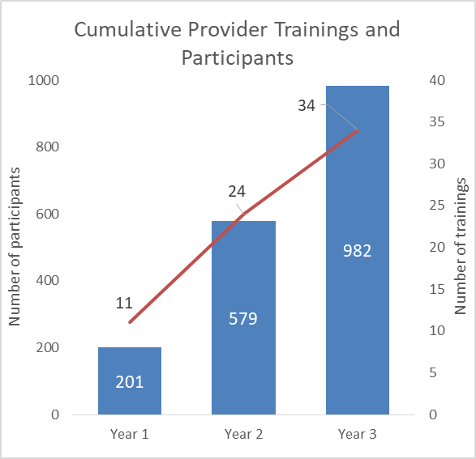

The chart below illustrates the total provider training participants per year.
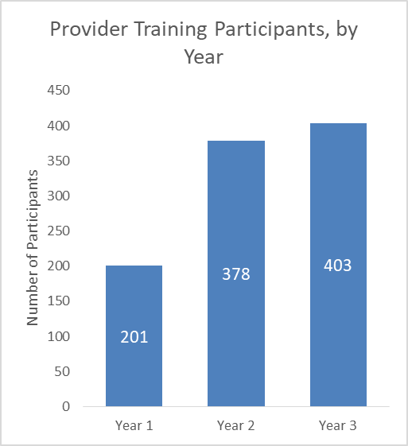

The chart below illustrates the self-reported roles of participants in the provider trainings. Overall, out of the 591 participants that provided information on their role, the majority self-identified as social workers (26%), case managers (25%), and nurses (19%).
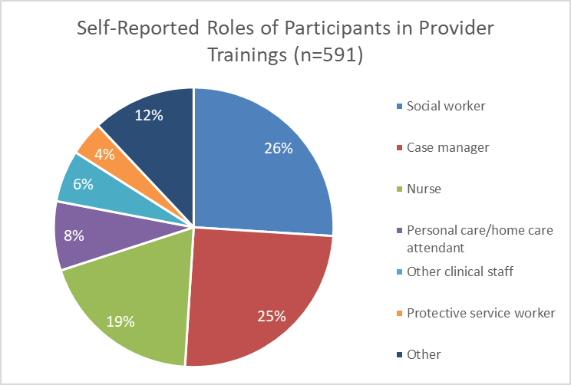

Outcomes Data

Opioid Use and Misuse Trainings
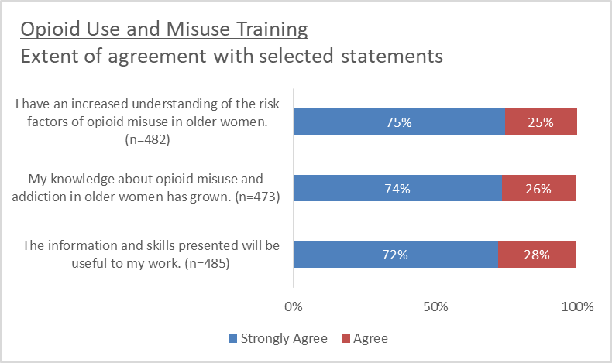
The chart below shows the percentage of participants that strongly agreed and agreed with statements regarding their knowledge of opioid misuse among older women after participating in an opioid use and misuse training.
In the last three years, 18 trainings were provided to staff at multiple partner agencies on opioid use and misuse among older women. A total of 489 of the 693 staff who participated in those trainings completed a survey evaluation, for a response rate of 71%. Nearly all survey respondents reported a positive experience with the training and knowledge gains in each topic covered in the training.
Three quarters of survey respondents strongly agreed and the remaining quarter agreed that as a result of the training they have an increased understanding of the risk factors of opioid misuse and about opioid misuse and addiction in older women. 72% strongly agreed and 28% agreed that the information and skills presented would be useful to their work.
Training participants were asked to complete follow-up surveys at three- and six-months after the training date. Out of the 35 participants who completed a follow-up survey, almost half (47%) indicated they had used the knowledge or skills from the training in their work with older women. The majority used the training to assess and identify potential patterns of abuse/misuse among older women and felt comfortable addressing the situation with the client or with their doctors to be sure medications are prescribed and used appropriately.
The chart below shows the extent of participants’ increase in knowledge in certain topics after attending the opioid use and misuse training.
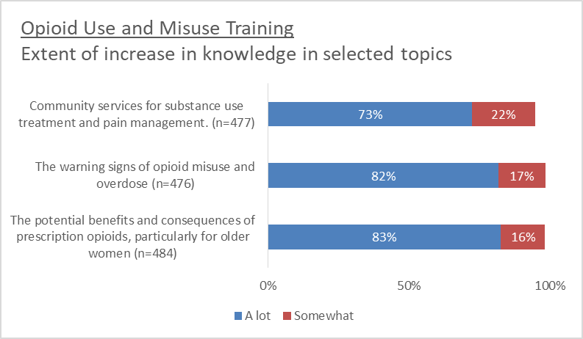
Nearly three quarters of all participants indicated that their knowledge of community services for substance use treatment and pain management had increased by a lot (73%). 82% of participants indicated that their knowledge of the warning signs of opioid misuse and overdose had substantially increased, and about the same percentage of participants indicated their knowledge on the potential benefits and consequences of prescription opioids, particularly for older women, had increased by a lot.

SBIRT and Motivational Interviewing (MI) Trainings
IHR staff conducted 5 trainings for staff at multiple partner agencies on Screening, Brief Intervention, and Referral to Treatment (SBIRT) through the POWER initiative. A total of 20 of the 120 staff who participated in those trainings completed a survey evaluation, for a response rate of 20%.
The chart below shows the percentage of participants that expressed greater facility with principles of Elder Screening, Brief Intervention, and Referral to Treatment (SBIRT) and comfort implementing this approach after participating in a training on SBIRT through the POWER initiative.
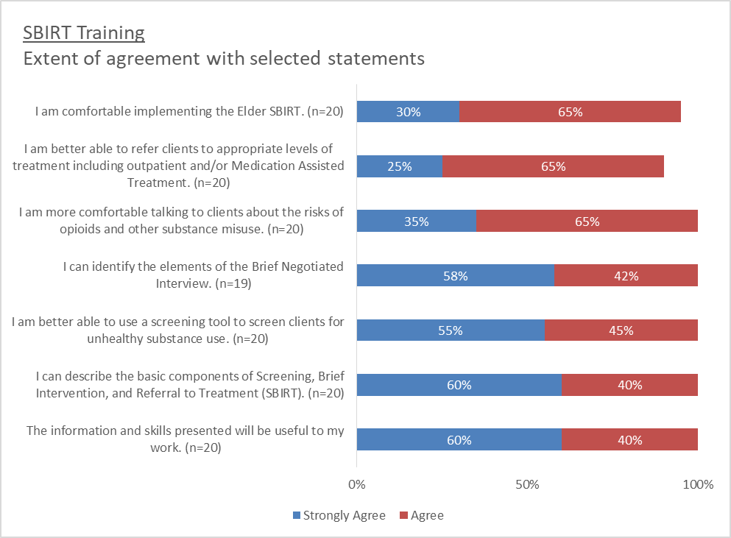
30% of survey respondents strongly agreed and 65% agreed that as a result of the training they were more comfortable implementing the Elder SBIRT. 25% strongly agreed and 65% agreed that as a result of the training they were better able to refer clients to appropriate levels of treatment including outpatient and/or Medication Assisted Treatment. 35% strongly agreed and 65% agreed that as a result of the training they were more comfortable talking to clients about the risks of opioids and other substance misuse. 55% strongly agreed and 45% agreed that as a result of the training they could identify the elements of the Brief Negotiated Interview. 55% strongly agreed and 45% agreed that as a result of the training they were better able to use a screening tool to screen clients for unhealthy substance use. 60% strongly agreed and 40% agreed that as a result of the training they could describe the basic components of SBIRT. 60% strongly agreed and 40% agreed that the information and skills presented would be useful to their work.
The chart below shows the percentage of participants that expressed greater facility with principles of Motivational Interviewing (MI) and comfort implementing this approach after participating in a training on MI through the POWER initiative.
. 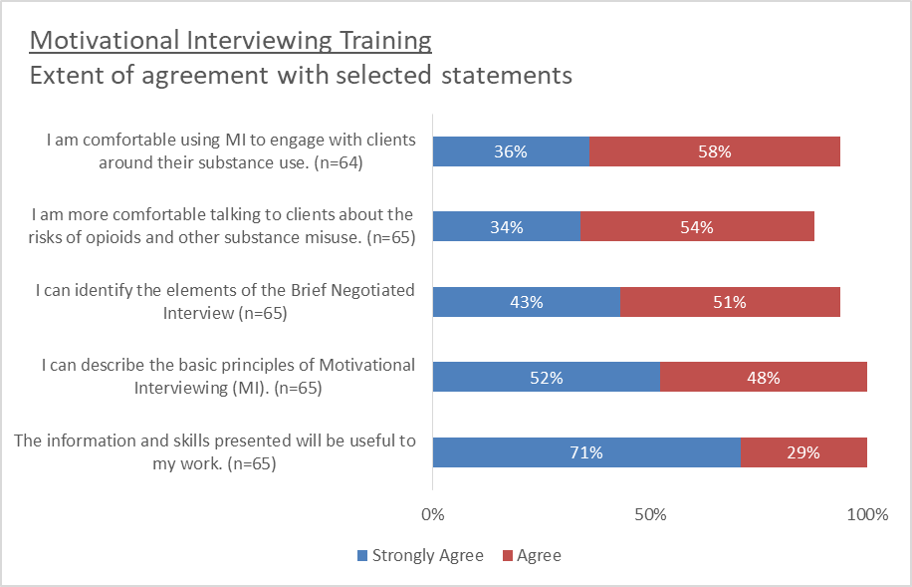
7 trainings were provided to staff at multiple partner agencies on Motivational Interviewing (MI) as part of the POWER initiative. A total of 65 of the 70 staff who participated in those trainings completed a survey evaluation, for a response rate of 93%.
36% of survey respondents strongly agreed and 58% agreed that as a result of the training they were comfortable talking to clients about the risks of opioids and other substance misuse. 43% strongly agreed and 51% agreed that as a result of the training they could identify the elements of the Brief Negotiated Interview. 52% strongly agreed and 48% agreed that as a result of the training they could identify the basic principles of Motivational Interviewing (MI). 71% strongly agreed and 29% agreed that the information and skills presented would be useful to their work.

Trauma and Seeking Safety Trainings
In the first year of the initiative, IHR staff piloted the Seeking Safety training. Following the training the decision was made to use a more general approach to training staff at partner agencies on trauma informed care. Staff from IHR conducted 3 trainings for staff at multiple partner agencies on trauma. A total of 82 of the 107 staff who participated in trauma informed trainings completed a survey evaluation, for a response rate of 77%.
The chart below shows the percentage of participants that expressed greater knowledge and comfort with the relationship between trauma and substance use after attending a trauma informed training. Seeking Safety pilot participants did not complete evaluations.
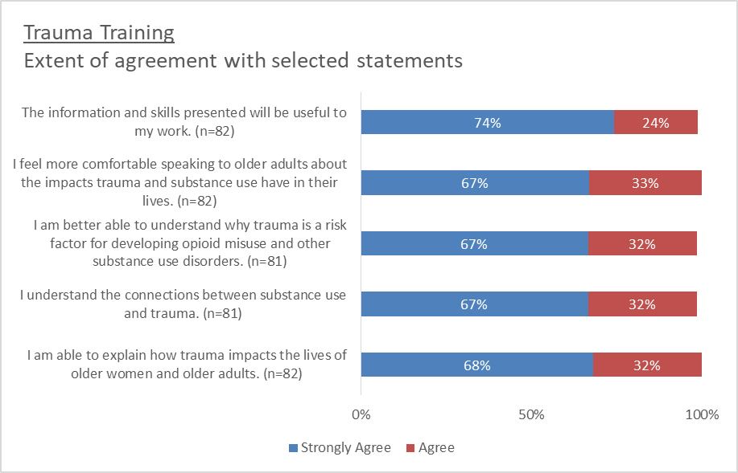
74% of survey respondents strongly agreed and 24% agreed that the information and skills presented would be useful to their work. 67% strongly agreed and 33% agreed that they felt more comfortable speaking to older adults about the impacts trauma and substance use have in their lives as a result of the training. 67% strongly agreed and 32% agreed that they were better able to understand why trauma is a risk factor for developing opioid misuse and other substance use disorders as a result of the training. 67% strongly agreed and 32% agreed that they understood the connections between substance use and trauma as a result of the training. 68% strongly agreed and 32% agreed that they were able to explain how trauma impacts the lives of older women and older adults as a result of the training.

Training Satisfaction
From evaluations across all trainings for elder service staff and providers, 96% of respondents stated that they intended to use the skills and information that they learned during the training in their future practice (n=627). Out of 571 responses, 66% had never participated in prior training on the topics addressed in their training, and 40% had never discussed the topic in their work previously.
The chart below shows the percentage of participants that expressed satisfaction with how the trainings were delivered.
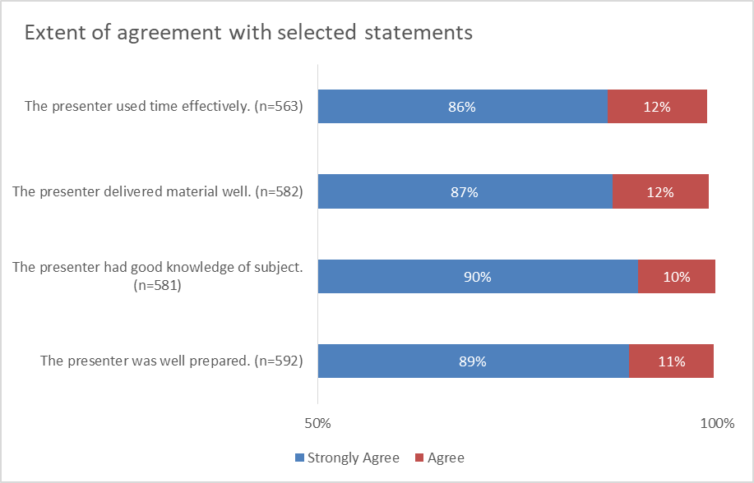
Survey respondents expressed a high degree of satisfaction with delivery of trainings. 86% of survey respondents strongly agreed and 12% agreed that the presenter used time effectively. 87% strongly agreed and 12% agreed that the presenter delivered the material well. 90% strongly agreed and 10% agreed that the presenter had good knowledge of the subject. 89% strongly agreed and 11% agreed that the presenter was well prepared. In responses to an open-ended question on their experience with the training, participants indicated that the instructor’s engaging manner and knowledge of the material were notable.

Qualitative Findings
Staff and provider training participants were asked how they intended to use knowledge and skills learned through the training. Most participants’ responses fell into four groups. The first group expressed their desire to use skills including motivational interviewing/OARS to actively engage patients and build rapport with them to effectively change patient behaviors. They felt the skills learned would be especially helpful in their interactions with patients who are reluctant to change. Participants expressed a desire to work together with patients/tenants/clients to determine their values and goals, and then to develop an action plan to achieve those goals.
A second set of participants indicated that the skills learned would be most valuable to them in terms of assessment and observation. They would be asking better questions and be able to better assess risk factors and warning signs. This would allow them to be able to recognize when someone needed help, have an empathetic conversation with them, and provide appropriate resource options without stigma.
A third set of respondents were most focused on education, not only for the patient/client, but especially for their colleagues and other staff members in their respective agencies. They noted an intent to pass the information along, and those in supervisory roles spoke of updating in-service trainings to include these skills. A fourth set of participants responded that they would use the training more generally, from a trauma-informed perspective. The training improved their awareness of their language when discussing sensitive topics, as well as understanding how to approach clients/patients who have experienced trauma. They also just felt the skillset made them more comfortable with initiating and having these difficult conversations with the elders in their care.

Consumer Interventions

Process Data
396 women (not all individual, as many women participated in multiple sessions) over the age of 55 participated in 42 workshops or presentations as part of the POWER initiative. Each consumer group focused on a different issue related to opioid use and misuse, medication management, alternative approaches to pain and stress management, and knowledge of community resources. In year 1, 125 older women participated in 10 sessions; in year 2, 163 women participated in 19 sessions, and, in year 3, 108 women participated in 13 sessions. The table below details the number of sessions and women over 55 that attended the sessions per program year.

Consumer Groups: Total Number of Trainings (Participants), by Year
Year | Session 1 | Session 2 | Session 3 | Session 4 | Session 5 | Session 6 | Other | Total
Year 1 (July 2017 - June 2018) | 1 (13) | 1 (9) | 1 (7) | 1 (4) | 1 (4) | 0 (0) | 5 (88) | 10 (125)
Year 2 (July 2018 - June 2019) | 2 (15) | 2 (13) | 2 (13) | 2 (9) | 2 (12) | 2 (11) | 7 (90) | 19 (163)
Year 3 (July 2019 - June 2020) | 4 (30) | 0 (0) | 0 (0) | 4 (34) | 0 (0) | 5 (44) | 1 (n)* | 14 (108)
Total | 7 (58) | 3 (22) | 3 (20) | 7 (47) | 3 (16) | 7 (55) | 13 (178) | 43 (396)
*Number of participants in this event (a Medication Take Back Night) was not recorded
The table below, along with information on number of sessions and participants seen above, displays the number of surveys collected by session. Overall, the survey response rate was 55% across the program period.
Consumer Groups: Number of trainings, participants and surveys collected
Training type | Total number of trainings | Total number of participants | Total number of surveys (response rate)
Session 1: Building Your Wellness Toolbox | 7 | 58 | 26 (45%)
Session 2: Managing Pain and Stress | 3 | 22 | 8 (36%)
Session 3: Using Mindfulness to Notice Pain and Stress | 3 | 20 | 12 (60%)
Session 4: Pain Management with Opioids | 7 | 47 | 26 (55%)
Session 5: Alternative Options for Pain and Stress Management | 3 | 16 | 11 (69%)
Session 6: Advocating for Your Needs/Med Management | 7 | 55 | 36 (65%)
Other trainings | 13 | 178 | N/A
Total | 43 | 396 | 119 (55%)

The chart below illustrates the cumulative increase in consumer group sessions and participants from Year 1 to Year 3.
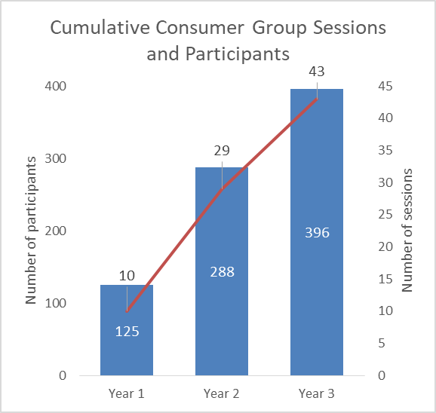
The chart below illustrates the total consumer group participants per program year.
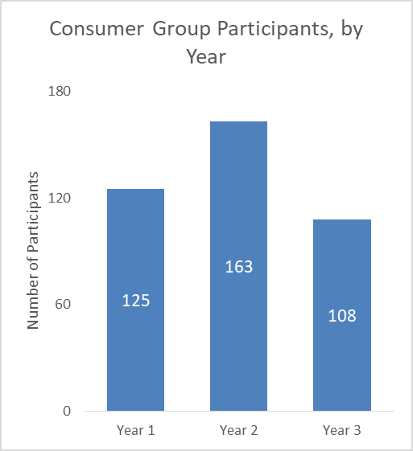

Outcomes Data

Opioid Use and Misuse
The chart below shows the percentage of women over the age of 55 who completed an evaluation that strongly agreed and agreed with each selected statement after they attended a session on the topic of opioid use and misuse.
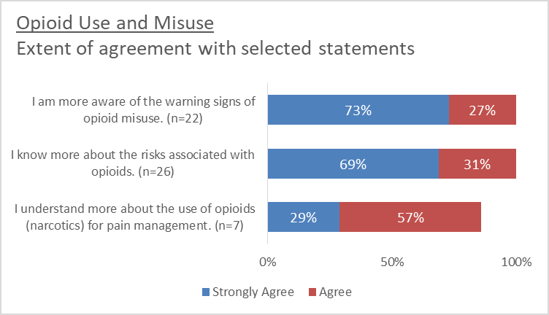
In the last three years, 10 presentations were provided to women over the age of 55 at multiple partner agencies on the topic of opioid use and misuse. A total of 34 of the 69 women who participated in those presentations completed a survey evaluation, for a response rate of 49%.
73% of survey respondents strongly agreed and 27% agreed that after participating in the presentation they were more aware of the warning signs of opioid misuse. 69% strongly agreed and 31% agreed that after participating in the presentation they knew more about the risks associated with opioids.

Medication Management
The chart below shows the percentage of women over the age of 55 who completed an evaluation that strongly agreed and agreed with each selected statement after they attended a session on the topic of medication management.
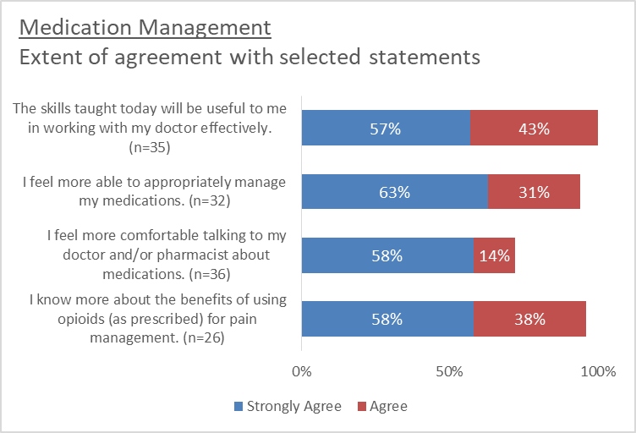
In the last three years, 14 presentations were provided to women over the age of 55 at multiple partner agencies on the topic of medication management. A total of 62 of the 107 women who participated in those presentations completed a survey evaluation, for a response rate of 58%.
58% of survey respondents strongly agreed and 14% agreed that after the presentation they felt more comfortable talking to their doctor and/or pharmacist about medications. 63% strongly agreed and 31% agreed that after participating in the presentation they felt better able to appropriately manage their medications. 57% strongly agreed and 43% agreed that the skills they learned during the presentation will be useful to them in working with their doctor effectively. 58% strongly agreed and 38% agreed that after participating in the presentation they knew more about the benefits of using opioids (as prescribed) for pain management.

Alternative Approaches to Pain and Stress Management
The chart below shows the percentage of women over the age of 55 who completed an evaluation that strongly agreed and agreed with each selected statement after they attended a session on the topic of alternative approaches to pain and stress management.
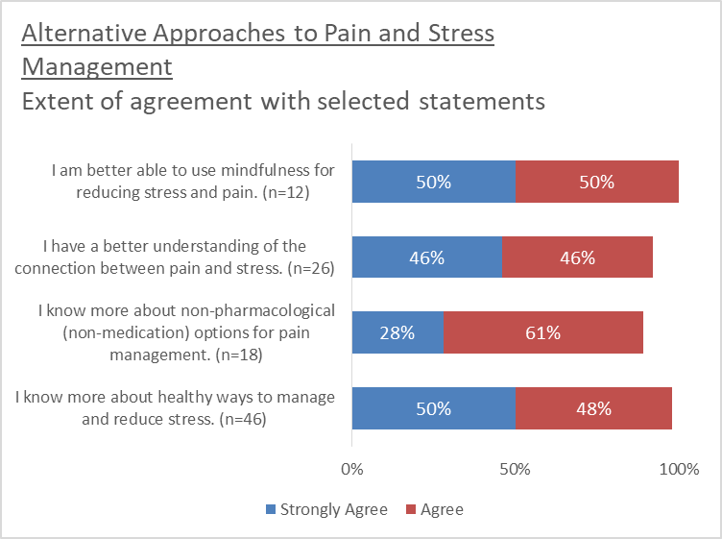
In the last three years, 16 presentations were provided to women over the age of 55 at multiple partner agencies on the topic of alternative approaches to stress and pain management. A total of 57 of the 117 women who participated in those presentations completed a survey evaluation, for a response rate of 49%.
50% of survey respondents strongly agreed and 50% agreed that after participating in the presentation they were better able to use mindfulness for reducing stress and pain. 46% strongly agreed and 46% agreed that after participating in the presentation they better understood the connection between pain and stress. 28% strongly agreed and 61% agreed that after the presentation they knew more about non-pharmacological (non-medication) options for pain management. 50% strongly agreed and 48% agreed that after the presentation they knew more about healthy ways to manage and reduce stress.
The chart below shows the percentage of women over the age of 55 who completed an evaluation that stated that they were very likely and somewhat likely to use the selected pain management strategies.
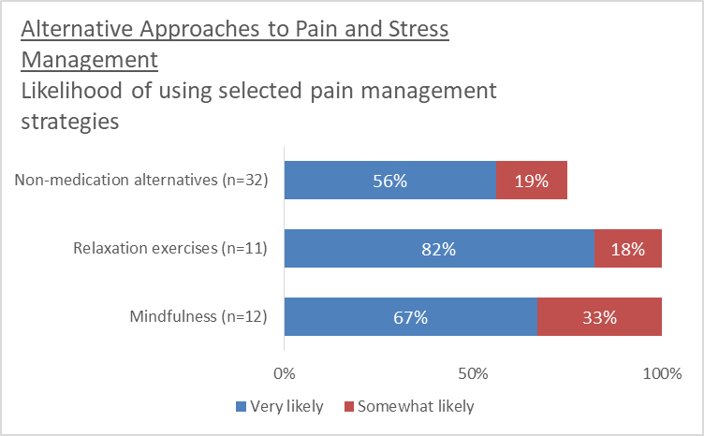
In the last three years, 13 presentations were provided to women over the age of 55 at multiple partner agencies on the topic of alternative approaches to pain and stress management. A total of 49 of the 83 women who participated in those presentations completed a survey evaluation, for a response rate of 59%.
56% of survey respondents stated they were very likely and 19% somewhat likely to use non-medication alternatives. 82% stated they were very likely and 18% were somewhat likely to use relaxation exercises as an alternative pain management strategy. 67% stated they were very likely and 33% somewhat likely to use mindfulness as an alternative pain management strategy.

Knowledge of Community Resources
The chart below shows the percentage of women over the age of 55 who completed an evaluation that strongly agreed and agreed with each selected statement after they attended a session on the topic of knowledge of community resources.
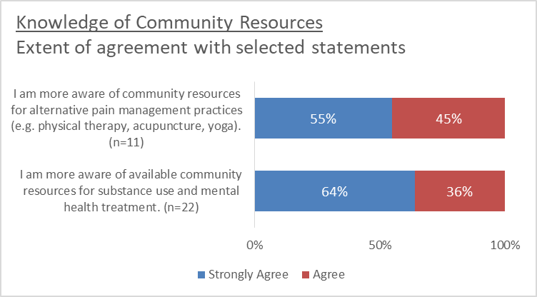
In the last three years, 10 presentations were provided to women over the age of 55 at multiple partner agencies on the topic of community resources. A total of 37 of the 63 women who participated in those presentations completed a survey evaluation, for a response rate of 59%.
64% of survey respondents strongly agreed and 36% agreed that after the presentation they were more aware of available community resources for substance use and mental health treatment. 55% strongly agreed and 45% agreed that after the presentation they were more aware of community resources for alternative pain management practices (e.g. physical therapy, acupuncture, yoga.)

Public Information Campaign
As part of POWER, one of our goals was to distribute informational brochures and flyers to older women about medication misuse and prescription opioids. Our formative evaluation indicated that given the characteristics of this population, print media and handouts would be one of the most well received ways to spread information to older women. Information disseminated included copies of the SAMHSA's current RX Pain series campaign materials, handbooks about alcohol and medications from BSAS (in four languages), medication journals; we also included the National Institute on Aging how to talk to your doctor self-advocacy handbooks, and information about our program. We handed out copies of a brochure called "Prevent Misuse of Prescription Drugs" which gives information about different brand names of opioids, sedatives, and depressants, and provides basic safety tips on following doctors' directions, safe storage, and appropriate disposal. Approximately 11,297 pieces of information was distributed during the life of this grant.
Type of Outreach Activity | # distributed/attended
Print Materials Distribution | 11,297 Print materials distributed
Television Appearances | 4 TV appearances
Capacity Building
Opioid Task Force D.A. Ryan | 7 meetings
Conferences | 7 conferences
Town Halls | 2 meetings
Meetings with partners | 53 meetings
Other Public Outreach | 11 events/activities
Advisory Committee | 8 meetings

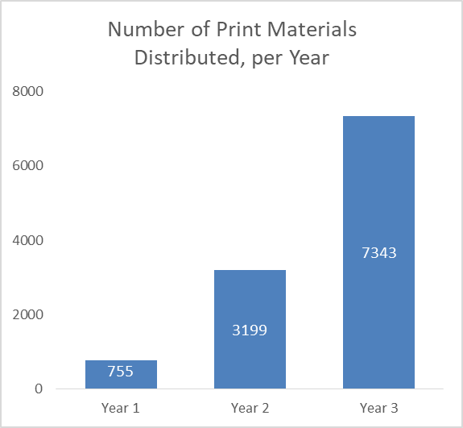

Significant Project Results:

Program Conclusion

Challenges
The major continued challenge we faced during this project was the need to first raise the level of consciousness in geriatric and elder care services around substance use. Most of our partner agencies and other community organizations did not prioritize substance use prevention, screening, or treatment as part of their standard levels of care. Though the risks of the opioid crisis are beginning to gain attention in the elder care field nationally, the interest in substance use services varies drastically at the local level. Part of our work therefore continued to be consciousness raising and capacity building among elder care systems in our target communities. We continued to educate the influencers in these systems about the need for increased prevention services. Gaining this level of attention is a continual challenge, as all services in the elder care field are already saturated with many other priorities. To overcome this challenge, we embarked on our Public Information Campaign disseminating information throughout the community, presented at multiple community events such as the District Attorneys Opioid Task Force Committee meetings, the Home Care Aide Councils Annual Spring Conference, the Somerville Cambridge Annual Elder Fair, and the Town of Winchesters Town Hall Meetings.
A significant challenge encountered was engaging doctors from the Geriatrics Department at Cambridge Health Alliance. Though doctors seem to be aware of the negative effects of opioids in the general population, there was mixed reception about the need for these preventative interventions within the elderly clients that the CHA Geriatrics program serves. When framed within the context of pain management skills and stress reduction, there has been widespread agreement on the value of those interventions, but the direct correlation to opioid misuse prevention has not seemed to be as high a priority with certain medical professionals. The framing of this project, both for targeted staff and older women, continued to be a point of consideration and revision as we learned how to best relay the facts of how opioid misuse and its associated risks affect older women. To overcome this challenge, we continued to present at various hospital locations affording us the opportunity to present to Gerontologists in attendance, and allowing us additional opportunities to further the discussion within the Geriatrics Department of other local area hospitals.
Another obstacle we encountered was obtaining support for the full implementation of the SBIRT protocol from our community partners. Though many recognized the issue of opioid misuse and would like to strengthen their staffs’ skills to intervene, the process of fully implementing SBIRT into their organizations’ work flow proved to be a concern for some. Issues that were raised were the inability to add new screening tools to their electronic medical records (EMR), the difficulty of adding more documentation to staffs’ workload, and the amount of time tracking the use of SBIRT and fidelity might consume. To overcome this challenge, we acknowledged that these are all legitimate issues, and continued to work with our partners to creatively solve the problem. One potential solution was with our Cambridge Health Alliance partners, in that they might be able to take a screening tool module used in the EMR of another program in the hospital and transfer it into their EMR configuration as well. With other partners, we continued to provide training on motivational interviewing and the brief negotiated interview algorithm to booster staffs’ capacity for having difficult conversations with their clients around opioid misuse, while we continued to trouble shoot issues of fully implementing the full SBIRT protocol.

Lessons Learned
The POWER project staff learned valuable lessons throughout the 3-year grant in their work with elder women. The first lesson learned was that an integral part of recovery for elder women is working to increase their self-esteem by identifying purpose. To accommodate this need, POWER provided training and one Recovery Purpose Group at the Elder Service Plan Gore Street, Cambridge, MA location. The POWER Project Coordinator worked closely with the group lead so that the group could continue past the life of this grant. Unfortunately, due to privacy issues with the groups’ location, they were unable to conduct any follow-up groups. To compensate, training sessions for CHA's Elder Services clinicians on IHR's POWER project Wellness Series and Opioid Workshops were conducted. At the time of this writing, we still anticipate that these clinicians will integrate the Wellness Series into this already established system without issue.
The greatest lesson learned from a consumer perspective was at the onset of COVID-19. During the life of this grant, we greatly underestimated how “tech-savvy” our older population of women are. With the immediate facility closures and the inability to conduct in-person groups with our consumers, action was taken to provide virtual group meetings that our consumers were extremely receptive to. In hind-sight, incorporating these virtual meetings into the projects regular programming would have afforded the opportunity to include our homebound elders on a regular basis.

Successes
Successes during the life of this grant included the expansion of the POWER project into the neighboring community of Malden, MA community. This expansion allowed for a broader area of impact
and the integration of the Opioid 101 training into the Home Care after Care Organization's new hire orientation and yearly in-service trainings. We were very successful creating new partnerships in Malden conducting two Opioid trainings for Mystic Valley Elder Services, training 242 healthcare providers and one Trauma Informed Training for approximately 80 healthcare providers. In addition, the expansion into the Malden area provided POWER to opportunity to conduct consumer coffee hour groups at the Heritage Senior Housing Complex.
Another great success was the taping of a three part series Opioid 101 Training Workshop through the MA Executive Office of Elder Affairs. IHR successfully contracted with this office to create a webinar series based upon the POWER Project Opioid Training Workshop. This training will be available after the life of this grant to all new employees and as a yearly in-service training to the staff members of the State of Massachusetts Executive Office of Elder Affairs. It will also be on the Executive Office’s website, as well as our website and on the BSAS website.
Also noteworthy was an invitation from the State of Massachusetts District Attorney's Office to attend and present information regarding Opioid Use and Elder Women at the District Attorney's monthly Opioid Task Force Meetings, which will be held in numerous communities. This invitation afforded us the opportunity to present and network with approximately 100 law enforcement officers, healthcare workers, and council on aging staff state-wide.

Evaluation Conclusion

Recommendations from Training Participants
Providers and staff who completed surveys following trainings offered recommendations for how to build on benefits from POWER activities. Many respondents expressed interest in extending their learning on topics presented through the POWER curriculum through extended discussions around exercises, case studies and role play or video examples of approaches for working with more reluctant or complex clients. To keep role play exercises flowing comfortably, some respondents suggested providing prompts for different roles.
Participants offered several suggestions of logistical improvements to trainings as well. These including building in time for breaks, breaking the training into two sessions, with one training session and then return in a few weeks to discuss issues the trainees had in the field; and provision of or guidance around bringing lunch. Some respondents recommended greater use of handouts or printed guides, and presentations. Respondents also suggested emailing the materials and pre-work in advance, so trainees could come to the sessions with prepared examples and questions.
Respondents would like more information on how to approach doctors with their concerns, accessing treatment/crisis intervention, alternatives to opioids for pain management, and PTSD/depression as they relate to substance use. Inclusion of topics specific to LGBT and non-binary individuals was also recommended.

Recommendations from Key Stakeholders
As part of our final evaluation of the POWER initiative, two group interviews were conducted with Program Coordinators from partnering elder service agencies and other key stakeholders. A survey was administered to stakeholders who were unable to participate in the group interviews. Participants in these activities were asked for their recommendations for how to build on the benefits to their organizations and the community from the POWER initiative.
Many interview participants expressed interest in additional webinars, blogs, and other virtual resources, as well as more workshops/trainings to continue building awareness of opioid use and misuse among older populations. One respondent recommended continued engagement of community partners as resources to better support older women around risk with opioid use disorders. Some respondents shared plans to build on the knowledge and skills gained in the POWER training.
Discussion of new challenges these organizations are facing due to the COVID-19 pandemic included concerns about elder isolation exacerbating depression and substance misuse/abuse. Older adults and women are especially afraid to leave their homes, which may lead to self-medicating escapism. In light of what will potentially be overwhelmed resources, staff will have to be diligent in identifying and addressing barriers to access for these consumers/clients. Continued POWER training will be important, considering high staff turnover. Another pandemic-related concern is that the number of deaths in this population will necessitate socially distant funeral services and grief support for surviving loved ones (especially considering women tend to live longer and therefore end up alone). When asked how POWER programming can be updated to better support these organizations through the pandemic, interviewees responded that Dr. Nuzzolo should stay the course. Some additional content about older men could be helpful, but it is important that POWER maintains its engaging workshop model that offers more practical than theoretical advice and emphasizes the human perspective.

Limitations
There are some limitations to the evaluation design and data sources that are important to note. First, the budgetary constraints necessitated limitations in our evaluation of the initiative. While process data was collected on all activities of the POWER initiative, evaluation of outcomes related to every component of the initiative was not feasible. We elected to focus on key supports offered to partnering agency staff and providers and consumers. Further, lack of funding for incentives likely limited participation in evaluation activities.
The combination of budgetary constraints and OMB regulations also limited responsiveness of the evaluation to changes in programming over time. It is possible that modifications to survey items to reflect program changes may have allowed for more robust findings.
Some items in both the staff/provider training surveys and consumer activity surveys may also be subject to social desirability bias, in which respondents select answers that are likely to be viewed favorably by others. Further, the interpretation of the provider/staff and consumer findings is limited due to the response rates, and we cannot determine if the survey findings are representative of the full population of providers, staff and consumers in the relevant agencies. This is particularly true regarding evaluation of consumer activities. However, although the survey data taken alone has limitations, the results are consistent with findings from the key informant evaluation activities, which lends credibility to the survey findings.
Regarding evaluation activities with key informants, although a larger group of stakeholders were invited to participate in the interviews and survey, given the timing of final evaluation activities with COVID-19, many individuals were unable to participate. As such the data ultimately represent the perspectives of only a small set of individuals, and it is possible that other stakeholders may have different perspectives on POWER implementation and impact. Furthermore, some items in the evaluation surveys and interviews may be subject to social desirability bias, as described above for the key informant interviews and survey.
COVID –related closings also significantly impacted implementation of all activities planned for the final quarter.

Conclusion
Taken together, the evaluation data provide evidence that the IHR POWER initiative was effective and that the initiative achieved its overarching goal. The combined evaluation findings are very positive and support the conclusion that POWER has increased elder service staff and providers’ capacity to provide effective support to consumers around opioid use and prevention of misuse; medication management; linking with community-based treatment resources, and alternative approaches to stress and pain management; and increased consumers’ capacity to care and advocate for themselves.
Key stakeholders indicated that the POWER initiative met or exceeded their expectations, changing the way their staff worked with older women or approached consumers with substance use concerns, as well as equipping them to handle substance use/misuse issues that arise with consumers. Staff were observed to be comfortable discussing substance use with consumers; using motivational interviewing to engage them as needed and applying a trauma-informed approach to their work with older consumers. Participants in POWER programming universally benefitted from the print materials, particularly the training for providers and non-providers. The most significant organizational changes participants reported as a result of POWER were the workshop/coffee hour/small group discussions with older women, the integration of older women’s issues into their program assessments, and staff’s overall ease and comfort initiating conversations about substance use with older women. Consumers noted feeling more comfortable talking to providers about substance use, and agency staff noted this change among their clients.
Overall, the combined quantitative and qualitative evaluation findings highlight a range of programmatic successes and positive outcomes that have been achieved over the grant period. In addition to these positive outcomes, the evaluation data also indicate areas of ongoing need that can inform the focus of future work.

Significant Developments – COVID-19

Change in functionality of IHR due to COVID-19
In accordance with State and local policy, The Institute for Health and Recovery immediately implemented the decisions and policies needed to facilitate closing our offices and working remotely. To ensure the safety of our consumers, women 55+, we cancelled all scheduled in-person workshops and Senior Center coffee hours. In addition, all senior centers and elder care organizations, including geriatric hospital units, were closed.
We continued to work remotely to assure our consumers had continued access to all the services the POWER Project offered. We remained in close contact with Mystic Valley Elder Services, the Malden Housing Authority, the Somerville Council on Aging, the Somerville Housing Authority, the Cambridge Council on Aging, and the Cambridge Housing Authority. We continued to stay in contact with all of our community partners so that we could continue to help direct those in need of services. (See Program Attachment Change in functionality of IHR due to COVID-19)

Appendices

Appendix A Goals and Objectives
Goal 1: Among 30 women ages 55+ in Somerville and Cambridge increase the knowledge and understanding of the potential risks and benefits of opioids, increase the self-reported ability to identify and manage risks of opioid use, misuse, and/or active disease in themselves and others. *
* In Year 3, the service area was expanded to include Malden and the target number of women to engage was increased to 45. Also in Year 3, the following text was added: Increase understanding of stress management, pain management alternatives, and physical therapy and coping skills.

Objective 1.1 | Distribute 100 informational brochures and flyers on prescription opioid misuse and pain in older women to 4 community sites (increasing to a total of 10 community sites over the three year period) that regularly serve women in Cambridge, Somerville.*  *Malden was added to the service area in Year 3. | Year 1: 755 brochures distributed
Objective 1.1 |  | Year 2:  3,199 brochures and flyers
Objective 1.1 |  | Year 3:  7,343 brochures and flyers
Objective 1.2 | Make at least 2 appearances on local cable access TV shows annually to discuss the intricacies of opioid use in older women, including the dangers, particularly in relation to older women. *  *In Year 3 italicized text was changed to “the relationship to pain, pain management and/or trauma.” | Year 1:  2 appearances
Objective 1.2 |  | Year 2:  1 appearance
Objective 1.2 |  | Year 3:  1 appearance
Objective 1.3* | Through at least two supportive groups annually held at partner agency sites, reach out to and engage a minimum of 15 women, ages 55+ to provide information on the risks and benefits of opioids as well as strategies and skills for addressing concerns around this topic such as tips for medication management and storage, skills to facilitate active collaboration with prescribing doctors, tools to identify risk factors and referrals.  *In Year 3 italicized text was changed to “providing strategies and skills for addressing stress and pain to prevent the initiation of opioids or the misuse of opioid medication already prescribed. Other topics will include..” | Year 1:  2 groups (8 participants)
Objective 1.3* |  | Year 2:  6 groups (32 participants)
Objective 1.3* |  | Year 3:  9 groups (78 participants)
Objective 1.4 | Through educational presentations held at partner agency sites in Cambridge and Somerville, engage a minimum of another 15 women ages 55+ to provide information on the risks and benefits of opioids as well as providing strategies for assessing risk in self and others, and tips in how to minimize risks.  * In Year 2 italicized text was changed to “and other creative participation strategies”  Y3: Objective 1.4 was changed to “Educate women on stress, the impact of stress and the connection between pain and stress, and non-pharmacological options for pain management.” | Year 1:  2 groups (8 participants)
Objective 1.4 |  | Year 2:  6 groups (32 participants)
Objective 1.4 |  | Year 3:  9 groups (78 participants)
Goal 2 (Y1 &2): Among at least 30 women ages 55+ in Somerville and Cambridge, increase the awareness of the prevalence and causes of trauma/psychological pain in older women, the link between psychological pain and chronic physical pain, and provide them with coping mechanisms and tools to address their own trauma and/or psychological pain.
Objective 2.1 | Through two groups held at partner sites, educate at least the same 15 women ages 15+ on the connection between trauma, emotional pain and physical pain. | Year 1:  2 groups (20 participants)  Year 2:  4 groups (28 participants)
Objective 2.2 | In supportive groups, offer these same 15 women psycho-education and skill building interventions to manage psychological pain, including some elements of the intervention Seeking Safety, that will specifically teach grounding and coping skills.*  * In Y2 Italicized text was changed to “and stress, such as deep breathing skills, relaxation, and mindfulness skills. | Year 1:  3 groups (29 participants)  Year 2:  6 groups (41 participants)
Objective 2.3 (Y1 only) | Use Cognitive Behavioral techniques, including mindfulness skills, with these same 15 women to assist them in managing and reducing stress. | Year 1:  2 groups (20 participants)
Objective 2.4 | Through educational presentations* held at partner agency sites in Cambridge and Somerville, engage a minimum of 15 additional women 55+ to provide information on the prevalence of trauma, common causes of trauma in older women, and the connection between psychological pain and physical pain. **  * “and other creative participation strategies” added in Y2.  **The following text added in Y2: “Explore the possibility of offering group treatment Seeking Safety at certain partner sites to women 55+ struggling with opioid misuse and trauma.” | Year 1:  3 groups (29 participants)  Year 2:  6 groups (41 participants)
Goal 2 (Y3): Increase the knowledge of at least 50 service providers at partner agencies about opioid use, misuse, and active disease. Increase the knowledge of risk factors and potential benefits of opiates for relief, and increase understanding of and access to medication assisted treatment, treatment options specifically geared towards older women.
Objective 2.1 | Provide training to at least 30 new staff at partner agencies and local community sites on the use of opioids in older women and their high risk for abuse. This training will include information on risks and benefits, warning signs of misuse, and referral information. | Year 3:  8 trainings (318 participants)
Objective 2.2 | Provide all staff trained in any of the above interventions with information on community based substance use disorder and mental health treatment and resources, including Medication Assisted Treatment if needed, and provide instruction on making referrals. | Year 3:  8 trainings (318 participants)
Objective 2.3 | Continue building relationships with the potential new partners identified in Years 1 and 2 (at least the five other healthcare and community service providers in Cambridge, Somerville and Malden serving women 55+; including hospitals, city housing authorities, and women’s shelters), in order to offer trainings and resources around substance use, opioid misuse, and trauma in older women. | Year 3:  2 meetings held with healthcare and community service organizations
Objective 2.4 | In collaboration with partner agency staff, integrate information about opioid use, misuse and active disease into existing programming at partner agencies to increase the knowledge of opioid risks and benefits, pain management resources and treatment strategies in women ages 55+. | Year 3:  Webinar series produced (employee new hire orientation for the state department and yearly training), and materials distributed during provider trainings
Goal 3 (Y1&2): Among women ages 55+ in Somerville and Cambridge, increase understanding of and access to alternative methods of chronic physical pain management, like physical therapy and acupuncture, while also teaching simple pain management skills to use on their own.
Objective 3.1 | In collaboration with partner agency staff, integrate information about alternative pain management options into existing programming at partner agencies to increase the knowledge of other pain management resources and strategies in women ages 55+. | Year 1:  2 groups (13 participants)
Objective 3.1 |  | Year 2:  4 groups (25 participants)
Objective 3.2 | Through the same groups offered to 30* women per year, and through integration into pre-existing programming at partner agency sites, teach basic mindfulness techniques to older women and provide information about mindfulness related workshops and activities within the community.  *15 women in Y2 | Year 1:  2 groups (20 participants)
Objective 3.2 |  | Year 2:  4 groups (28 participants)
Goal 4*: Increase the knowledge of at least 20 service providers at partner agencies about substance/opioid use and misuse, and the correlation between trauma/psychological distress and use of opiates and relief, and screening tools and treatment options specifically geared towards older women.
*Goal 3 in Y3, with a goal of serving at least 50 providers, and the italicized text omitted.
Objective 4.1 (3.1 in Y3) | Y1: Provide at least 40 staff members at Somerville Cambridge Elder Services (SCES), Cambridge Council on Aging (CCOA), and Somerville Council on Aging (SCOA) with basic training on substance use disorders, addiction, and the links between substance use and trauma, particularly in older women.  Y2: Provide at least 40 staff members at partner agency sites, including Somerville Cambridge Elder Services and Cambridge Health Alliance, with Part 2 Elder SBIRT trainings (following up on the introduction trainings done at these sites in year 1), with a focus on motivational interviewing and effectively using the brief negotiated interview (BNI) algorithm to discuss substance use issues, and particularly opioid misuse, with older women clients.  Y3: Train at least 10 more social work and clinical staff at partner agency sites on issues of trauma, substance use and older adults, including the possibility for trainings on Trauma Informed Care. | Year 1:  2 trainings (27 participants)
Objective 4.1 (3.1 in Y3) |  | Year 2:  1 training (15 participants)
Objective 4.1 (3.1 in Y3) |  | Year 3:  1 training (80 participants)
Objective 4.2 (Y1&2) | Y1: Provide these same staff with education around opiates and their high risk for abuse, particularly in older women.  Y2: Provide training to at least 30 new staff at partner agencies and local community sites on the use of opioids in older women and their high risk for abuse. This training will include information on risks and benefits, warning signs of misuse, and referral information | Year 1:  1 training (30 participants)
Objective 4.2 (Y1&2) |  | Year 2:  9 trainings (345 participants)
Objective 4.3 (Y1&2) | Train 30 staff from partner agencies and new community partners in Elder SBIRT with several follow up training sessions to strengthen learning and effective use of the tool, using in kind support from IHR and BSAS staff specializing in SBIRT. | Year 1:  3 trainings (82 participants)
Objective 4.3 (Y1&2) |  | Year 2:  1 training (15 participants)
Objective 4.4 (Y1&2) | Y1: Train 10 social work and clinical staff from SCES and CHA Geriatrics Department in the Seeking Safety interventions for individual use, including adaptations IHR has been involved with in the past to enhance this intervention for older women.  Y2: Train at least 10 more social work and clinical staff (additional from year 1) at partner agency sites on issues of trauma, substance use, and older adults, including the possibility for trainings on using Seeking Safety with Older Adults. | Year 1:  1 training (10 participants)
Objective 4.4 (Y1&2) |  | Year 2:  0 trainings
Objective 4.5 (Y1&2) | Provide all staff trained in any of the above interventions with information on community based substance use disorder and mental health treatment and resources, including Medication Assisted Treatment if needed, and provide instruction on making referrals. | Year 1:  3 trainings (82 participants)
Objective 4.5 (Y1&2) |  | Year 2:  1 training (15 participants)
Objective 4.6 (Y1&2) | Y1: Continue to build relationships with at least five other healthcare and community service providers in Cambridge and Somerville serving women 55+ (including hospitals, city housing authorities, and women’s shelters) in the first year to collect information about their training and service needs in regard to substance use and opioids in women 55+, and work to meet those needs in years two and three.  Y2: Continue building relationships with the potential new partners identified in Year 1, (at least the five other healthcare and  community service providers in Cambridge and Somerville serving women 55+; including hospitals, city housing authorities, and women’s shelters), in order to offer trainings and resources around substance use, opioid misuse, and trauma in older women | Year 1:  32 meetings held with healthcare and community service organizations
Objective 4.6 (Y1&2) |  | Year 2:  19 meetings held with healthcare and community service organizations
Goal 4 (Y3): Increase the knowledge and skills of at least 20 service providers at partner agencies about screening tools and treatment options Screening Brief Intervention Referral to Treatment (SBIRT) and Motivational Interviewing (MI) techniques.
Objective 4.1 (Y3) | Train at least 20 new staff, from both current partner agencies and potential new community partners, in Elder SBIRT for older women with several follow up training sessions to strengthen learning and effective use of the tool, using in kind support from IHR and BSAS staff specializing in SBIRT. | Year 3:  1 training (5 participants)
Objective 4.2 (Y3) | Provide at least 20 staff members at partner agency sites, including Somerville and Cambridge Elder Services and Cambridge Health Alliance, with Part 2 Elder SBIRT trainings (following up on the introduction trainings done at these sites in years 1 and 2), with a focus on motivational interviewing and effectively using the brief negotiated interview (BNI) algorithm to discuss substance use issues, and particularly opioid misuse, with older women clients. | Year 3:  1 training (5 participants)
Goal 5: Increase understanding among professionals*, health care and community service providers about feasible and effective interventions for addressing opiate use in women ages 55+.
* “including the Advisory Committee” added in Y3
Objective 5.1 | Y1: Engage in an exploratory information gathering process through work with community partners, the creation of the project’s advisory committee, and a formative evaluation process using key informant interviews and a focus group, all of which will serve the purpose of raising consciousness and building a foundational understanding about the relatively unknown and underserved issues related to opioid misuse and substance use disorders in older women in Cambridge and Somerville.  Y2 & 3: Continue holding quarterly Advisory Committee meetings for this project to both update on accomplished activities and to get feedback and advice on future project activities. Issues, concerns, and insights through these meetings will be documented into the evaluation process and a final report on the findings of this project and the lessons learned. | Year 1:  4 meetings
Objective 5.1 |  | Year 2:  2 meetings
Objective 5.1 |  | Year 3:  2 meetings
Objective 5.2 | Conduct process and outcome evaluations on each component of the intervention, using lessons learned to refine successive iterations of interventions and activities over the 3 years of the project. | Year 1: Process and outcome work was completed.
Objective 5.2 |  | Year 2:  Process and outcome work was completed, and revised as necessary.
Objective 5.2 |  | Year 3:  Process and outcome work was completed, and revised as necessary.
Objective 5.3 | Share information about substance use, and in particular opioids, in women 55+ with the Somerville/Cambridge community and disseminate relevant information and findings to professional and community audiences including through social media and an email listserv, community forums, and at professional conferences as opportunities arise. | Year 1: Outside of material distribution during presentations, 2 events were held to disseminate relevant information to the target population
Objective 5.3 |  | Year 2: Outside of material distribution during presentations, 4 events were held to disseminate relevant information to the target population
Objective 5.3 |  | Year 3: Outside of material distribution during presentations, 5 events were held to disseminate relevant information to the target population

Appendix B Outcomes

1 | At least 100 informational brochures and flyers will be distributed to 4 community sites in year 1, and 100 informational brochures and flyers in year 2.
In year 1, 755 brochures and flyers were distributed across community sites.
In year 2, 3,199 brochures and flyers were distributed across community sites
In year 3, 7,343 brochures and flyers were distributed across community sites
2 | At least 2 appearances will be made on local cable access TV shows in year 1, and 2 appearances in year 2.
In year 1, 2 appearances were made on local cable access TV.
In years 2 and 3, 2 appearances were made on local cable access TV.
3 | CONSUMERS - 70% of women ages 55+ served through this project will increase their knowledge and awareness of opioids, particularly those that are prescribed, and their appropriate use including potential risks and benefits
 | In the last three years we provided 7 presentations to a total of 47 women over the age of 55 on this topic. Of the 26 women who completed an evaluation of these presentations, 58% “Strongly Agreed” and 38% “Agreed” that after participating in the presentation they knew more about the benefits of using opioids (as prescribed) for pain management. Of the 26 women who completed an evaluation of these presentations, 69% “Strongly Agreed” and 31% “Agreed” that after participating in the presentation they knew more about the risks associated with opioids.
4 | CONSUMERS - 70% of women ages 55+ served through this project will increase their knowledge and awareness of the warning signs of opioid misuse in themselves and others.
 | In the last three years we provided 7 presentations to a total of 47 women over the age of 55 that included discussion on these topics. Of the 22 women who completed an evaluation on this topic, 73% “Strongly Agreed” and 27% “Agreed” that after participating in the presentation they were more aware of the warning signs of opioid misuse.
5 | CONSUMERS - 70% of women ages 55+ served through this project will increase their self-reported ability to address medication concerns with providers and manage medications appropriately
 | In the last three years we provided 7 presentations to a total of 55 women over the age of 55 on this topic. Out of the 36 women who completed an evaluation on this topic, 58% “Strongly Agreed” and 14% “Agreed” that after the presentation they felt more comfortable talking to their doctor and/or pharmacist about medications. Of 32 women who completed an evaluation on this topic, 63% “Strongly Agreed” and 31% “Agreed” that after participating in the presentation they felt more able to appropriately manage their medications. Of 35 women who completed an evaluation on this topic, 57% “Strongly Agreed” and 43% “Agreed” that the skills they learned during the presentation will be useful to them in working with their doctor effectively.
6 | CONSUMERS - 70% of women ages 55+ served through this project will increase their knowledge and awareness of alternative methods to manage chronic pain.
 | In the last three years we provided 16 presentations to a total of 116 women over the age of 55 on these topics. Out of 46 women who provided an evaluation, 50% “Strongly Agreed” and 48% “Agreed” that after the presentation they knew more about healthy ways to manage and reduce stress. Out of 18 women who provided an evaluation, 28% “Strongly Agreed” and 61% “Agreed” that after the presentation they knew more about non-pharmacological (non-medication) options for pain management. Out of 12 women who completed an evaluation, 50% “Strongly Agreed” and 50% “Agreed” that after participating in the presentation they were better able to use mindfulness for reducing stress and pain.
7 | CONSUMERS - 70% of women ages 55+ served through this project will increase their knowledge and awareness of available community resources for older women for addressing both psychological and physical pain, and substance use issues.
 | In the last three years we provided 10 presentations to a total of 63 women over the age of 55 on these topics. Out of the 22 women who completed an evaluation, 64% “Strongly Agreed” and 36% “Agreed” that after the presentation they were more aware of available community resources for substance use and mental health treatment. Of the 11 women who completed an evaluation, 55% “Strongly Agreed” and 45% “Agreed” that after the presentation they were more aware of community resources for alternative pain management practices (e.g. physical therapy, acupuncture, yoga.)
8 | CONSUMERS - 70% of women ages 55+ served through this project will increase their intention to utilize alternative pain management strategies.
 | In the last three years we provided 13 presentations to a total of 83 women over the age of 55 that included discussion of utilizing alternative pain management strategies. Of the 12 women who completed an evaluation of this discussion, 67% stated they were “Very likely” and 33% “Somewhat likely” to use mindfulness as an alternative pain management strategy. Out of 11 women, 82% stated they were “Very likely” and 18% were “Somewhat likely” to use relaxation exercises as an alternative pain management strategy. Out of 30 women, 56% stated they were “Very likely” and 19% “Somewhat likely” to use non-medication alternatives.
9 | OPIOID TRAINING - 80% of staff at partner agencies trained through this project will increase their level of knowledge on substance use and addiction in older women, particularly with a focus on opioids and their potential consequences and benefits.
In the last three years, 18 trainings were provided to staff at multiple partner agencies on opioid use and misuse among older women. A total of 693 staff participated in those trainings. Out of 473 participants who completed the evaluation question, 74% “Strongly Agreed” and 26% “Agreed” that their knowledge about opioid misuse and addiction in older women grew as a result of the training. Nearly all participants who completed evaluations stated that their knowledge on the potential benefits and consequences of prescription opioids, particularly for older women, had increased, by a lot (82%) and somewhat (16%) (n=484).

We administered three- and six-month follow-up surveys to past training participants. Out of the 33 participants who completed a follow-up this quarter, one participant (47%) indicated using the knowledge or skills from the training in their work with older women.
10 | OPIOID TRAINING - 80% of staff at partner agencies trained through this project will increase their level of knowledge of the warning signs of opioid misuse
 | In the last three years, 18 trainings were provided to staff at multiple partner agencies on opioid use and misuse among older women. A total of 693 staff participated in those trainings. Out of 476 participants who completed the evaluation on this topic, nearly all stated that their knowledge on the warning signs of opioid misuse and overdose had increased, by a lot (82%) and somewhat (17%).
11 | OPIOID TRAINING - 80% of staff at partner agencies trained through this project will increase their level of knowledge of community services that can help address psychological and chronic physical pain for older women, and substance use disorders.
 | In the last three years, 18 trainings were provided to staff at multiple partner agencies on opioid use and misuse among older women. A total of 693 staff participated in those trainings. Out of 477 participants who completed the evaluation on this topic, nearly all stated that their knowledge on community services for substance use treatment and pain management had increased, by a lot (73%) and somewhat (22%).
12 | OPIOID TRAINING - 70% of staff at partner agencies trained through this project will report increased ability to assess risk factors in older women for opioid misuse.
 | In the last three years, 18 trainings were provided to staff at multiple partner agencies on opioid use and misuse among older women. A total of 693 staff participated in those trainings. Out of 482 participants who completed the evaluation question, 75% “Strongly Agreed” and 25% “Agreed” that as a result of the training they have an increased understanding of the risk factors of opioid misuse.
13 | OPIOID TRAINING - 80% of Staff members will integrate information presented on opioid use, misuse, and active disease, warning signs and risk factors into their future practice with older adults.
 | In the last three years, 18 trainings were provided to staff at multiple partner agencies on opioid use and misuse among older women. A total of 693 staff participated in those trainings. Of the 465 participants who responded to an evaluation item on this topic, 96% indicated that they intend to use the skill/information presented in the training in their future practice with older adults.
14 | TRAUMA INFORMED TRAINING - 70% of staff at partner agencies trained through this project will be better able to understand the role of trauma in their clients’ life.
 | In the last three years, 3 trainings were provided to staff at multiple partner agencies on trauma. A total of 107 staff participated in those trainings. Of 82 participants that completed this evaluation, 68% “Strongly Agreed” and 32% “Agreed” that they were able to explain how trauma impacts the lives of older women and older adults as a result of the training. Of 81 participants that completed this evaluation, 67% “Strongly Agreed” and 32% “Agreed” that they understood the connections between substance use and trauma as a result of the training. Of 81 participants that completed this evaluation, 67% “Strongly Agreed” and 32% “Agreed” that they were better able to understand why trauma is a risk factor for developing opioid misuse and other substance use disorders as a result of the training. Of 81 participants that completed this evaluation, 67% “Strongly Agreed” and 33% “Agreed” that they felt more comfortable speaking to older adults about the impacts trauma and substance use have in their lives as a result of the training.
15 | SBIRT/MI TRAINING - 50% of staff at partner agencies trained through this project will report increased ability to implement Elder SBIRT using MI techniques.
 | In the last three years, 3 trainings were provided to staff at multiple partner agencies on Elder SBIRT. A total of 102 staff participated in those trainings. Of the 20 participants who completed an evaluation on this topic, 30% “Strongly Agreed” and 65% “Agreed” that as a result of the training they were more comfortable implementing the Elder SBIRT. Of the 20 participants who completed an evaluation on this topic, 35% “Strongly Agreed” and 65% “Agreed” that as a result of the training they were more comfortable talking to clients about the risks of opioids and other substance misuse. Of the 20 participants who completed an evaluation on this topic, 55% “Strongly Agreed” and 45% “Agreed” that as a result of the training they could identify the elements of the Brief Negotiated Interview.
16 | SBIRT/MI TRAINING - 70% of staff at partner agencies trained through this project on SBIRT/MI will be better able to refer women to appropriate levels of treatment including inpatient/outpatient treatment and services as needed
 | In the last three years, 3 trainings were provided to staff at multiple partner agencies on Elder SBIRT. A total of 102 staff participated in those trainings. Of the 20 participants who completed an evaluation on this topic, 55% “Strongly Agreed” and 45% “Agreed” that as a result of the training they were better able to use a screening tool to screen clients for unhealthy substance use. Of the 20 participants who completed an evaluation on this topic, 25% “Strongly Agreed” and 65% “Agreed” that as a result of the training they were better able to refer clients to appropriate levels of treatment including outpatient and/or Medication Assisted Treatment.
17 | The project coordinator will reach out to at least five other healthcare or community services organizations serving women 55+ in Cambridge and Somerville in order to build relationships and discuss potential opportunities for project collaboration or information sharing.
18 | Partner Agencies will continue to integrate information presented through the POWER PROJECT regarding opioid use, misuse, and active disease in older women, into partner agencies existing programming after the life of this grant.
19 | Quarterly, project staff will generate a brief summary and analysis of process and outcome evaluation data that will inform future work and will be distributed to the Advisory Committee and other key actors.
 | In the three years of the program, project staff met with the Advisory Committee 8 times (4 meetings in Year 1, 2 meetings in Year 2, and 2 meetings in Year 3), meeting the objective of 8 Advisory Committee meetings across the span of the program. Process and outcome evaluation data was regularly shared with the Advisory Committee meetings across the span of the program.

Appendix C Logic Model
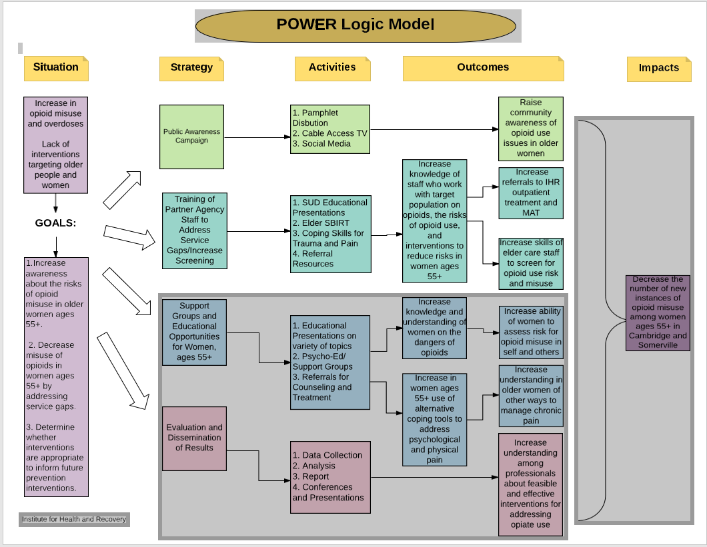

Appendix D Detailed Work Plan:
POWER Work Plan – Year 3
Institute for Health and Recovery
Goal 1: Among 45 women ages 55+ in Somerville, Cambridge, and Malden increase the knowledge and understanding of the potential risks and benefits of opioids, and increase the self-reported ability of these same women to identify and manage risks of opioid use, misuse, and/or addiction in themselves and others.
Objective 1.1. Distribute 150 informational brochures and flyers on prescription opioid misuse and pain in older women to 4 community sites that regularly serve older women in Somerville, Cambridge, and Malden.
Expected Outcome: At least 150 informational brochures and flyers distributed to 4 community sites in year 3.
Key Activities | Person(s) Responsible | YR3 (July 19 – June 20)
Key Activities | Person(s) Responsible | Q1 | Q2 | Q3 | Q4
- Review publications from state and federal agencies to identify potential new resources appropriate for dissemination to educate women 55+ on opioid use and misuse | PC, PI, BSAS staff | X | X
- Develop POWER publications on issues related to opioid use, misuse, addiction, and pain that are not covered in other identified materials | PC, PI | X | X
- Review publications with appropriate experts including POWER Advisory Committee | PC, PI, BSAS staff, OWH Project Officer | X | X | X
- Identify appropriate community sites for the dissemination of these pamphlets and develop arrangements for distribution of materials | PC, Partner Agency Staff |  |  | X | X
- Track rate of utilization of information resources (how many flyers/brochures dropped off quarterly) at all sites and refill as needed | PC |  |  | X | X
- Based on data collection of utilization, revise selection of resources, identified sites, and timeline for drop off and restocking as needed | PC, Partner Agency Staff, PI |  |  |  | X
Objective 1.2. Make at least 2 appearances on local cable access TV shows to discuss the intricacies of opioid use in older women, including the relationship to pain, pain management and/or trauma.
Expected Outcome: At least 2 appearances made on local cable access TV shows annually.
Key Activities | Person(s) Responsible | YR3 (July 19 – June 20)
Key Activities | Person(s) Responsible | Q1 | Q2 | Q3 | Q4
- Reach out to local cable access channels and existing shows relevant to or watched by women 55+ to secure spots for interviews and/or PSAs | PC |  | X | X | X
- Develop IHR’s content for PSA and/or interviews related to opioid misuse in women 55+ | PC, PI, OWH Project Officer |  |  | X | X
- Appear on shows with prepared material to present information to women 55+ about the complexities of opioids, including their risks and benefits. | PC |  |  | X | X
Objective 1.3. Through supportive groups held at partner agency sites, reach out to and engage a minimum of 20 women, ages 55+ during year three to provide information on the risks and benefits of opioids as well as providing strategies and skills for addressing stress and pain to prevent the initiation of opioids or the misuse of opioid medication already prescribed. Other topics will include tips for medication management and storage, skills to facilitate active collaboration with prescribing doctors, tools to identify risk factors and referrals.
Expected Outcome: Among women ages 55+, there will be a 65% increase in the knowledge and awareness of opioids, particularly those that are prescribed, and their appropriate use including potential risks and benefits.
Expected Outcome: Among women ages 55+, there will be a 65% increase in the knowledge and awareness of the warning signs of opioid misuse and overdose in themselves and others.
Expected Outcome: Among women ages 55+, there will be a 50% increase in the self-reported ability to assess risk of use/substance misuse in themselves and others.
Expected Outcome: Among women ages 55+, there will be a 60% increase in the self-reported ability to address medication concerns with providers and manage medications appropriately.
Key Activities | Person(s) Responsible | YR3 (July 19 – June 20)
Key Activities | Person(s) Responsible | Q1 | Q2 | Q3 | Q4
- Revise curriculum for groups based off feedback and evaluations. | PC, PI, OWH Project Officer | X | X
- Work with partner agencies to concretize logistics of group (start date, run time, recruiting methods, etc.) | PC, Partner Agency Staff | X | X | X
- Recruit for group membership at identified sites (including flyers, emails, published advertisements, and in person recruitment) | PC, Partner Agency Staff | X | X | X
- Conduct two groups at identified site locations using revised group curriculum. | PC, with supervision from PI |  |  | X | X
- Conduct post group evaluations and use information collected to revise group curriculum and protocols as needed for future groups | PC, ICH Evaluation Team, PI |  |  | X | X
Objective 1.4. Through the use of educational presentations and other creative participation strategies, engage a minimum of another 25 women ages 55+ at partner agency sites in Somerville, Cambridge, and Malden to provide information on the risks and benefits of opioids as well as providing strategies for assessing risk in self and others, and tips in how to minimize risks. Facilitated discussions and question and answer sessions will increase participants’ knowledge on opioids.
Expected Outcome: Among women ages 55+, there will be a 65% increase in the knowledge and awareness of opioids, particularly those that are prescribed, and their appropriate use including potential risks and benefits.
Expected Outcome: Among women ages 55+, there will be a 65% increase in the knowledge and awareness of the warning signs of opioid misuse and overdose in themselves and others.
Expected Outcome: Among women ages 55+, there will be a 50% increase in the self-reported ability to assess risk of use/substance misuse in themselves and others.
Expected Outcome: Among women ages 55+, there will be a 60% increase in the self-reported ability to address medication concerns with providers and manage medications appropriately.
Key Activities | Person(s) Responsible | YR3 (July 19 – June 20)
Key Activities | Person(s) Responsible | Q1 | Q2 | Q3 | Q4
- Revise presentation content to fit the needs of identified sites and their particular sub populations of women ages 55+ and work with partner sites to identify creative solutions to attract more participants for events. | PC, PI, OWH Project Officer | X | X | X | X
- Work with partner agency staff to set dates for presentations and informational events. | PC, Partner Agency Staff | X | X | X | X
- Engage in outreach and advertising to attract women ages 55+ to upcoming presentations and events at partner agency sites as needed | PC, Partner Agency Staff | X | X | X | X
- Conduct presentations and other events | PC, with supervision from PI |  | X | X | X
- Conduct post group evaluations and use information collected to revise group curriculum and protocols as needed for future groups | PC, ICH Evaluation Team, PI |  | X | X | X
Goal 2: Among at least 30 women ages 55+ in Somerville, Cambridge, and Malden increase awareness of the prevalence and causes of trauma/psychological pain in older women, the link between psychological pain and chronic physical pain, and provide them with coping mechanisms and tools to address their own trauma and/or psychological pain.
Objective 2.1. Through supportive groups held at partner sites referenced above, educate at least the same 20 women ages 55+ on the connection between trauma, emotional pain, and physical pain.
Expected Outcome: Among women ages 55+, there will be a 50% increase in the knowledge and awareness of the connection between trauma/psychological pain and chronic physical pain.
Key Activities | Person(s) Responsible | YR3 (July 19 – June 20)
Key Activities | Person(s) Responsible | Q1 | Q2 | Q3 | Q4
- Revise curriculum for this portion of group to focus more on the connections between trauma, stress, and chronic pain. | PC, PI, IHR Trauma, OWH Project Officer Supervisor | X | X | X | X
- Conduct post group evaluations to measure learning and increased skill abilities and use information collected to revise curriculum as needed for future groups | PC, ICH Evaluation Team, PI |  | X | X | X
Objective 2.2. In the supportive groups, offer these same 20 women psycho-education and skill building interventions to manage psychological pain and stress, such as deep breathing skills, relaxation exercises, and mindfulness skills.
Expected Outcome: Among women ages 55+, there will be a 50% increase in the knowledge and awareness of the connection between trauma/psychological pain and chronic physical pain.
Expected Outcome: Among women ages 55+ there will be a 50% increase in the self-reported ability to cope with their own psychological distress.
Key Activities | Person(s) Responsible | YR3 (July 19 – June 20)
Key Activities | Person(s) Responsible | Q1 | Q2 | Q3 | Q4
- Revise the curriculum for this portion of group to succinctly teach these skills and their connection to pain and trauma | PC, PI, IHR Trauma Supervisor, OWH Project Officer | X | X | X | X
- Conduct post group evaluations to measure learning and increased skill abilities and use information collected to revise curriculum as needed for future groups | PC, ICH Evaluation Team, PI |  | X | X | X
Objective 2.3. Through the use of educational presentations and other creative participation strategies, engage a minimum of another 10 women ages 55+ at partner agency sites in Somerville, Cambridge, and Malden to provide information on the prevalence of trauma, common causes of trauma in older women, and the connection between psychological pain and physical pain.
Expected Outcome: Among women ages 55+, there will be a 50% increase in the knowledge and awareness of the connection between trauma/psychological pain and chronic physical pain.
Key Activities | Person(s) Responsible | YR3 (July 19 – June 20)
Key Activities | Person(s) Responsible | Q1 | Q2 | Q3 | Q4
- Develop presentation content and event materials covering issues related to trauma, psychological pain, and physical pain | PC, PI, IHR Trauma Supervisor, OWH Project Officer | X | X
- Work with partner agency staff to set dates for presentations and informational events | PC, Partner Agency Staff | X | X | X | X
- Engage in outreach and advertising to attract women ages 55+ to upcoming presentations and events at partner agency sites as needed | PC, Partner Agency Staff | X | X | X | X
- Conduct presentations and other events | PC, with supervision from PI, IHR Trauma Supervisor |  | X | X | X
- Conduct post group evaluations to measure learning and increased skill abilities and use information collected to revise curriculum as needed for future groups and reporting purposes | PC, ICH Evaluation Team, PI |  | X | X | X
Objective 2.4. Explore the possibility of offering the group treatment, Trauma Informed Care/Seeking Safety, at certain partner sites to women ages 55+ who are struggling with opioid misuse and the effects of trauma.
Expected Outcome: Among women ages 55+ there will be a 50% increase in the self-reported ability to cope with their own psychological distress.
Key Activities | Person(s) Responsible | YR3 (July 19 – June 20)
Key Activities | Person(s) Responsible | Q1 | Q2 | Q3 | Q4
- Work with staff at partner agencies to explore the feasibility of offering Trauma Informed Care/Seeking Safety group at their site(s) | PC | X | X
- Work with partner agency staff who have agreed to host a Trauma Informed/Seeking Safety group to schedule the group and manage other logistical needs relevant to beginning the group | PC, PI |  | X | X
- Advertise and recruit for this group in a trauma informed manner, respecting the privacy of potential group members who are approached to gauge their interest | PC, IHR Trauma Supervisor, Partner agency staff |  | X | X
- Conduct post group evaluations and use collected information for evaluation and reporting purposes and to modify future renditions of group as needed | PC, ICH Evaluation Team, PI |  |  | X | X
Goal 3: Among women ages 55+ in Somerville, Cambridge, and Malden increase understanding of and access to alternative methods of chronic physical pain management, like physical therapy and acupuncture, while also teaching simple pain management skills to use on their own.
Objective 3.1. In collaboration with partner agency staff integrate information about alternative pain management options into existing programming at partner agencies to increase the knowledge of other pain management resources and strategies in women ages 55+.
Expected Outcome: Among women ages 55+ there will be a 60% increase in the knowledge and awareness of alternative methods to manage chronic pain.
Expected Outcome: Among women ages 55+ there will be a 60% increase in the knowledge and awareness of available community resources for older women for addressing both psychological and physical pain.
Key Activities | Person(s) Responsible | YR3 (July 19 – June 20)
Key Activities | Person(s) Responsible | Q1 | Q2 | Q3 | Q4
- Identify pre-existing programming related to pain at partner agency sites and work with involved staff to incorporate education about other local resources for pain management | PC, Partner Agency Staff | X | X
- Provide partner agencies with information about local resources, workshops and activities focused on pain management to share with clients | PC | X | X | X | X
Objective 3.2. Through integration into pre-existing programming at partner agency sites, teach basic mindfulness techniques to 20 older women and provide information about mindfulness related workshops and activities within the community.
Expected Outcome: Among women ages 55+ there will be a 60% increase in the knowledge and awareness of Alternative methods to manage chronic pain.
Expected Outcome: Among women ages 55+ there will be a 50% increase in the self-reported ability to manage their own chronic physical pain.
Expected Outcome: Among women ages 55+, there will be a 40% increase in the self-reported intention to utilize new alternative pain management strategies.
Key Activities | Person(s) Responsible | YR3 (July 19 – June 20)
Key Activities | Person(s) Responsible | Q1 | Q2 | Q3 | Q4
- Revise resource database of pain management created in years one and two with new resources as they become available and share with partner sites | PC | X | X | X | X
- Provide women in groups with information about local resources, workshops and activities focused on pain management; also share these resources with partner agency staff | PC |  |  | X | X
Goal 4: Increase the knowledge and skills of at least 50 service providers at partner agencies about substance use and opioid misuse in older women, the links between older women’s histories of trauma/psychological distress and use of opiates for relief, and screening tools and treatment options specifically geared towards older women.
Objective 4.1. Provide at least 20 staff members at partner agency sites, including Somerville Cambridge Elder Services and Cambridge Health Alliance, with Part 2 Elder SBIRT trainings (following up on the introduction trainings done at these sites in years1and 2), with a focus on motivational interviewing and effectively using the brief negotiated interview (BNI) algorithm to discuss substance use issues, and particularly opioid misuse, with older women clients.

Expected Outcome: Among staff working with women 55+ at partner agencies there will be a 70% increase in the self-reported ability to implement the Elder SBIRT.
Expected Outcome: Among staff working with women ages 55+ at partner agencies, there will be a 70% increase in the self-reported ability to assess risk in older women for opioid misuse.
Expected Outcome: Among staff working with women ages 55+ at partner agencies, there will be an 80% increase in the self-reported ability to refer women to appropriate levels of treatment including outpatient and/or Medication Assisted Treatment, as needed.
Key Activities | Person(s) Responsible | YR3 (July 19 – June 20)
Key Activities | Person(s) Responsible | Q1 | Q2 | Q3 | Q4
- Work with partner agency leadership staff to schedule follow up trainings for SBIRT Part 2 trainings on effectively using motivational interviewing and the BNI. Manage logistics of scheduling and holding trainings | PC, IHR SBIRT Trainer, Key Partner Agency Staff | X | X | X | X
- Present trainings to staff at identified partner agency sites and enter data into evaluation outcome tracking tools | PC, IHR SBIRT Trainer |  | X | X | X
- Conduct post training process evaluations and use information gathered to revise training content and learning objectives as needed | PC, ICH Evaluation Staff |  | X | X | X
Objective 4.2 Provide training to at least 45 new staff at partner agencies and local community sites on the use of opioids in older women and their high risk for abuse. This training will include information on risks and benefits, warning signs of misuse, and referral information.
Expected Outcome: Among staff working with women ages 55+ at partner agencies, there will be an 80% increase in the level of knowledge on substance use and addiction in older women, particularly with a focus on opioids and their potential risks and benefits.
Expected Outcome: Among staff working with women ages 55+ at partner agencies, there will be an 80% increase in the level of knowledge of warning signs of opioid misuse and overdose.
Expected Outcome: Among staff working with women ages 55+ at partner agencies, there will be an 80% increase in the level of knowledge of auxiliary risk factors for older women in misuse of opiates (e.g. trauma).
Key Activities | Person(s) Responsible | YR3 (July 19 – June 20)
Key Activities | Person(s) Responsible | Q1 | Q2 | Q3 | Q4
- Revise training material developed in years 1 and 2 relevant to opioids, opioid misuse, and the dangers of opioids in older women 55+ | PC, PI, OWH Project Officer | X | X
- Work with partner agency leadership staff to identify appropriate staff for trainings and to create training plan and timetable | PC, IHR SBIRT Trainer, Key Partner Agency Staff | X | X
- Present trainings to staff at partner agency sites and enter data into evaluation outcome tracking tools | PC, IHR SBIRT Trainer | X | X | X | X
- Conduct post training process evaluations and use information gathered to revise training content and learning objectives as needed | PC, ICH Evaluation Staff | X | X | X | X
Objective 4.3. Train at least 30 new staff, from both current partner agencies and potential new community partners, in Elder SBIRT for older women with several follow up training sessions to strengthen learning and effective use of the tool, using in kind support from IHR and BSAS staff specializing in SBIRT.
Expected Outcome: Among staff working with women 55+ at partner agencies there will be a 70% increase in the self-reported ability to implement the Elder SBIRT.
Expected Outcome: Among staff working with women ages 55+ at partner agencies, there will be a 70% increase in the self-reported ability to assess risk in older women for opioid misuse.
Expected Outcome: Among staff working with women ages 55+ at partner agencies, there will be an 80% increase in the self-reported ability to refer women to appropriate levels of treatment including outpatient and/or Medication Assisted Treatment, as needed.
Key Activities | Person(s) Responsible | YR3 (July 19 – June 20)
Key Activities | Person(s) Responsible | Q1 | Q2 | Q3 | Q4
- Work with partner agency leadership staff to identify appropriate agency staff for Elder SBIRT trainings and to create training plan and timetable | PC, BSAS Staff, IHR SBIRT Trainer, Partner Agency Staff | X | X | X | X
- Present Elder SBIRT trainings to staff at partner agency sites; and enter data into evaluation outcome tracking tools | PC, IHR SBIRT Trainer |  | X | X | X
- Conduct post training process evaluations and use information gathered to revise training content and learning objectives as needed | PC, IHR SBIRT Trainer, BSAS Staff, ICH Evaluation Staff |  | X | X | X
- Work with partner agency staff to get feedback on training and develop follow up training schedule for more in depth Elder SBIRT trainings | PC, IHR SBIRT Trainer, Partner Agency Staff |  |  | X | X
Objective 4.4. Train at least 5 more social work and clinical staff (additional from years 1 and 2) at partner agency sites on issues of trauma, substance use, and older adults, including the possibility for trainings on using Trauma Informed Care/Seeking Safety with Older Adults.
Expected Outcome: Among staff working with women 55+ at partner agencies there will be an 80% increase in the self-reported ability to Implement Trauma Informed/Seeking Safety curriculum
Expected Outcome: Among staff working with women ages 55+ at partner agencies, there will be an 80% increase in the level of knowledge of auxiliary risk factors for older women in misuse of opiates (e.g. trauma).
Key Activities | Person(s) Responsible | YR3 (July 19 – June 20)
Key Activities | Person(s) Responsible | Q1 | Q2 | Q3 | Q4
- Revise existing material and develop new material as needed on the connection between trauma and substance use, and how this specifically relates to older adults, in particular women | IHR Trauma Supervisor, PC | X | X
- Work with partner agency leadership staff to identify appropriate agency staff for Trauma Informed Care/Seeking Safety trainings and to create training plan and timetable | PC, IHR Trauma Supervisor, Key Partner Agency Staff | X | X
- Present Trauma Informed Care/Seeking Safety trainings to staff at partner agency sites and enter data into evaluation outcome tracking tools | PC, IHR Trauma Supervisor | X | X | X
- Conduct post training process evaluations and use information gathered to revise training content and learning objectives as needed | PC, IHR Trauma Supervisor, ICH Evaluation Staff | X | X | X
Objective 4.5. To continue to increase impact and to integrate the group work of the POWER Wellness Series into these already established systems during year three of this grant, sustainability strategies will include training at least 5 more social work and clinical staff (additional from years 1 and 2) at partner agency sites on leading educational focused series groups.
Expected Outcome: Among staff working with women 55+ at partner agencies there will be an 80% increase in the self-reported ability to Implement the Wellness Series curriculum.
Expected Outcome: Among staff working with women ages 55+ at partner agencies, there will be an 80% increase in the level of knowledge of auxiliary risk factors for older women in misuse of opiates (e.g. trauma).
Key Activities | Person(s) Responsible | YR3 (July 19 – June 20)
Key Activities | Person(s) Responsible | Q1 | Q2 | Q3 | Q4
- Revise existing material and develop new material as needed on the connection between trauma and substance use, and how this specifically relates to older adults, in particular women | IHR Trauma Supervisor, PC | X | X | X | X
- Work with partner agency leadership staff to identify appropriate agency staff for trainings and to create training plan and timetable | PC, IHR Trauma Supervisor, Key Partner Agency Staff | X | X | X | X
Objective 4.6. Provide all staff trained in any of the above interventions with information on community based substance use disorder and mental health treatment and resources, including Medication Assisted Treatment if needed, and provide instruction on making referrals.
Expected Outcome: Among staff working with women ages 55+ at partner agencies, there will be an 80% increase in the level of knowledge of community services that can help address psychological and chronic physical pain for older women, substance use screenings, and overdose reversal options.
Expected Outcome: Among staff working with women ages 55+ at partner agencies, there will be an 80% increase in the self-reported ability to refer women to appropriate levels of treatment including outpatient and/or Medication Assisted Treatment, as needed.
Key Activities | Person(s) Responsible | YR3 (July 19 – June 20)
Key Activities | Person(s) Responsible | Q1 | Q2 | Q3 | Q4
- Update resource list compiled in Years 1 and 2 of local community based resources for SUD, OUD, and mental health treatment | PC, Advisory Committee, Partner Agency Staff | X | X
- Incorporate information about above resources into all staff trainings where appropriate, including information on how to make referrals | PC, IHR SBIRT Trainer, BSAS Staff | X | X | X | X
- Provide partner agency sites and staff with copies of resource lists | PC | X | X | X | X
Objective 4.7. Continue building relationships with the potential new partners identified in Years 1 and 2, (at least the five other healthcare and community service providers in Somerville, Cambridge, and Malden serving women 55+; including hospitals, city housing authorities, and women’s shelters), in order to offer trainings and resources around substance use, opioid misuse, and trauma in older women.

Expected Outcome: Build relationships with at least five other healthcare or community services providers serving women 55+ in Somerville, Cambridge, and Malden.
Key Activities | Person(s) Responsible | YR3 (July 19 – June 20)
Key Activities | Person(s) Responsible | Q1 | Q2 | Q3 | Q4
- Continued outreach to local service providers, including but not limited to the Somerville, Cambridge, and Malden Housing Authorities, Spaulding Hospital, the Women’s Center, and Mt. Auburn Hospital, to introduce POWER project | PC, PI, Advisory Committee | X | X | X | X
- Facilitate meetings with interested community providers to learn more about their service and training needs in relation to opioid use in women 55+ | PC | X | X | X
- Work with these newly interested community partners to bring staff trainings and support groups to women through the remainder of the project | PC |  | X | X | X
Goal 5: Increase understanding among professionals, including health care and community service providers, about feasible and effective interventions for addressing opiate use in women ages 55+.
Objective 5.1. Continue holding quarterly Advisory Committee meetings for this project to both update on accomplished activities and to get feedback and advice on future project activities. Issues, concerns, and insights through these meetings will be documented to integrate into the evaluation process and a final report on the findings of this project and lessons learned.
Expected Outcome: The Advisory Committee meets quarterly for life of project.
Key Activities | Person(s) Responsible | YR3 (July 19 – June 20)
Key Activities | Person(s) Responsible | Q1 | Q2 | Q3 | Q4
- Hold Advisory Committee meetings quarterly to report on progress of POWER’s goals and activities and receive feedback from committee | PC, PI, Advisory Committee | X | X | X | X
- Continue facilitating connections and conversations with relevant experts from Somerville and Cambridge. Facilitate conversation with community leaders in Malden throughout the third year of the project to introduce POWER to the Malden Community, facilitate conversation about the needs of women 55+ in relation to opioid use, and to continuously enhance POWER’s scope and efficacy | PC, Principle Investigator, Advisory Committee | X | X | X | X
Objective 5.2. Conduct process and outcome evaluations on each component of the intervention, using lessons learned to refine successive iterations of interventions and activities over the 3 years of the project.
Expected Outcome: Brief summaries and analysis of process and outcome evaluation tools to inform future work.
Key Activities | Person(s) Responsible | YR3 (July 19 – June 20)
Key Activities | Person(s) Responsible | Q1 | Q2 | Q3 | Q4
- Modify current evaluation forms developed for components of this project as needed based on feedback from trainers, prior participants, or Advisory Committee | PC, ICH Evaluation Staff | X | X | X
- Submit all evaluation forms to OWH for OMB clearance process as revisions occur | PC | X | X | X | X
- At the culmination of all staff trainings and support groups for women consumers, conduct evaluations and collect for analysis; outcome process tools will be used to track # of trainings, women age 55+ served, # of interventions, etc. | PC | X | X | X | X
- Evaluations will be analyzed and summarized to provide outcome information for federal quarterly reporting and to provide process feedback for revisions on interventions as needed in future renditions | PC, ICH Evaluation Staff | X | X | X | X
Objective 5.3. Share information about substance use, and in particular opioids, in women 55+ with the Somerville, Cambridge, and Malden communities and disseminate relevant information and findings to professional and community audiences including through social media and an email listserv, community forums, and at professional conferences as opportunities arise.

Expected Outcome: Findings disseminated to multiple venues.
Key Activities | Person(s) Responsible | YR3 (July 19 – June 20)
Key Activities | Person(s) Responsible | Q1 | Q2 | Q3 | Q4
- Engage with potential community and professional venues as opportunities present themselves about sharing the goals of the POWER project and any findings to date | PC, PI, Advisory Committee | X | X | X | X
- Present findings to interested venues | PC, PI |  | X | X | X
- Use social media to share information about POWER and to provide information about older women and substance use to the communities of Somerville, Cambridge, and Malden | PC, PI, OWH Project Officer | X | X | X | X
- Develop listserv of local community contacts, including partner agency staff and past staff training participants, to provide updates on the project and related information on opioids and older women including resources, data, and research new findings | PC, PI | X | X | X | X

Project Attachments - Promotional Materials

POWER Description
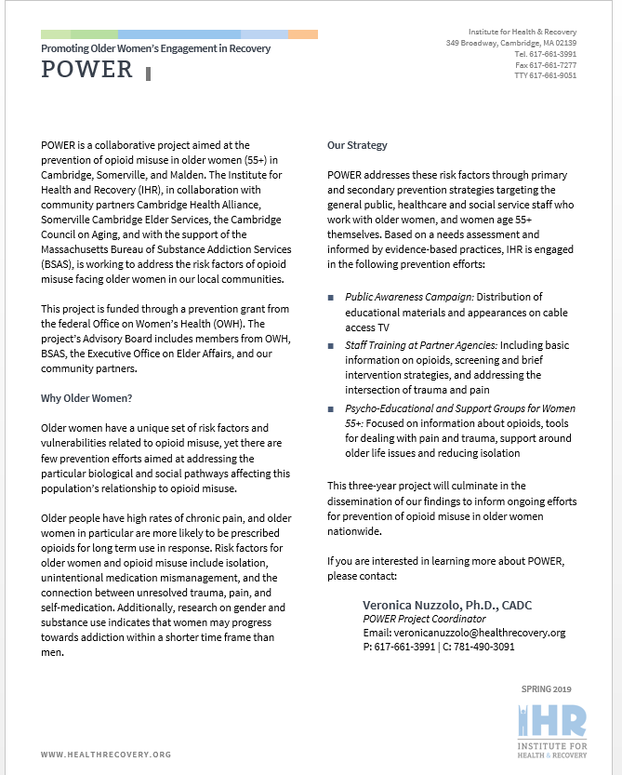

About IHR
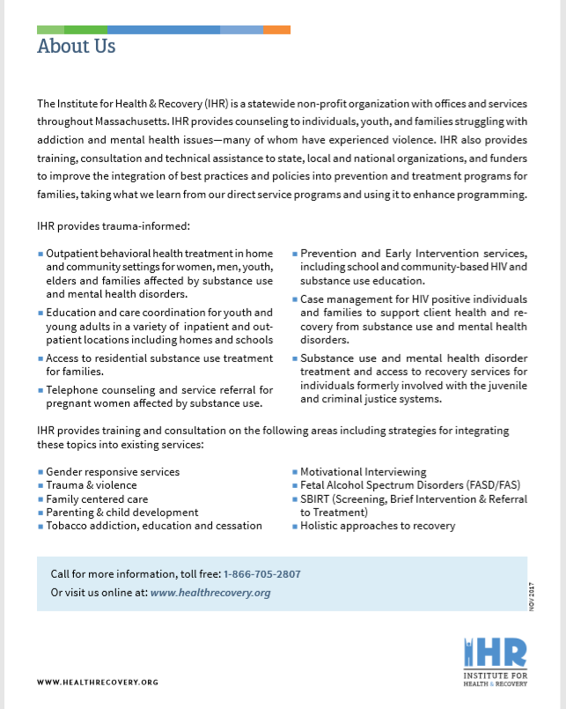

Talk to Your Doc
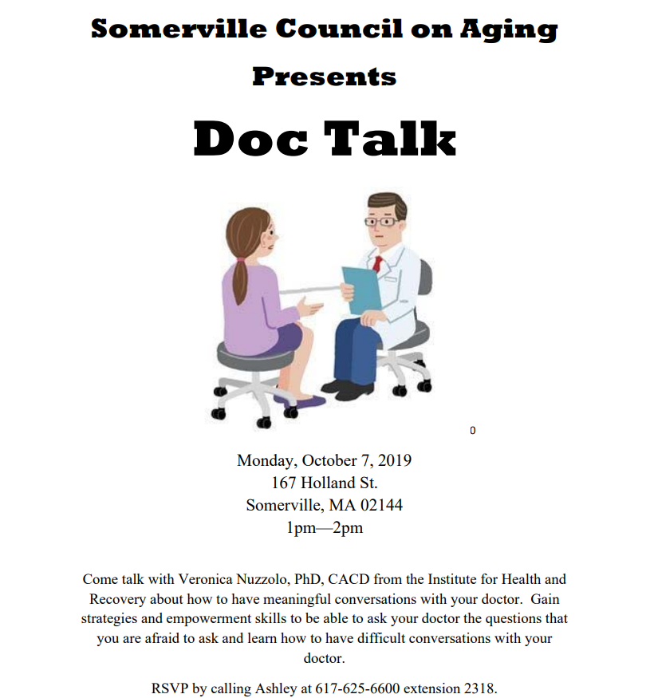

Staying Med Compliant
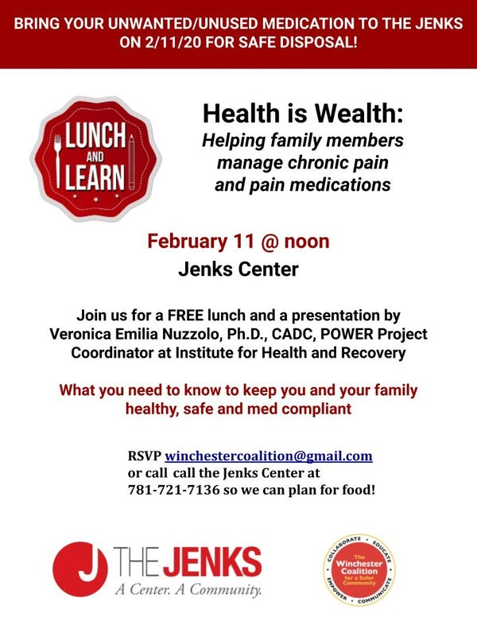
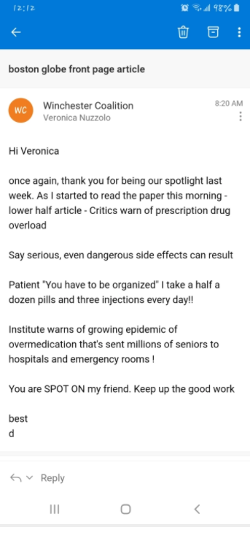

State of Massachusetts Opioid 101 Workshops
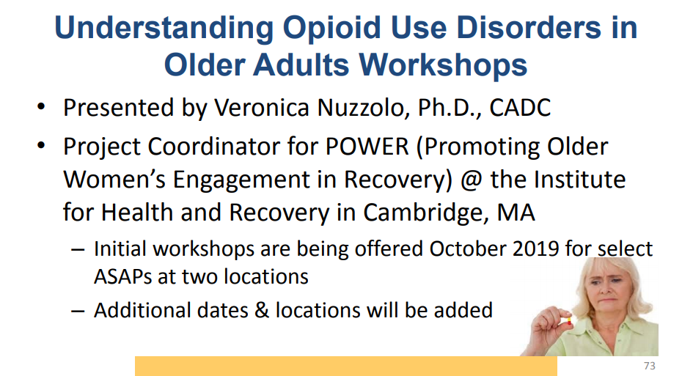

Key Note Speaking Events
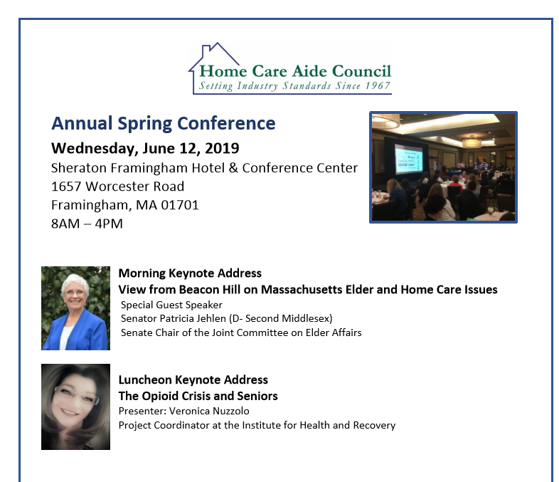
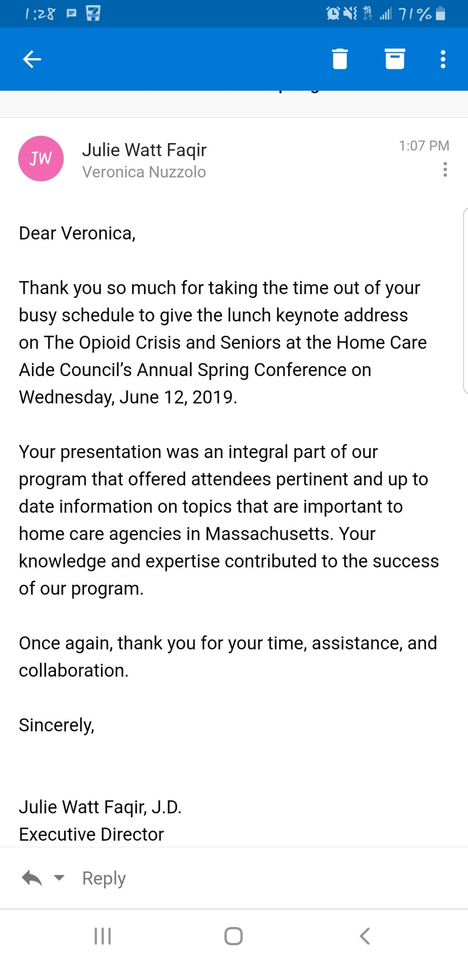

District Attorney Marian T. Ryan Opioid Task Force
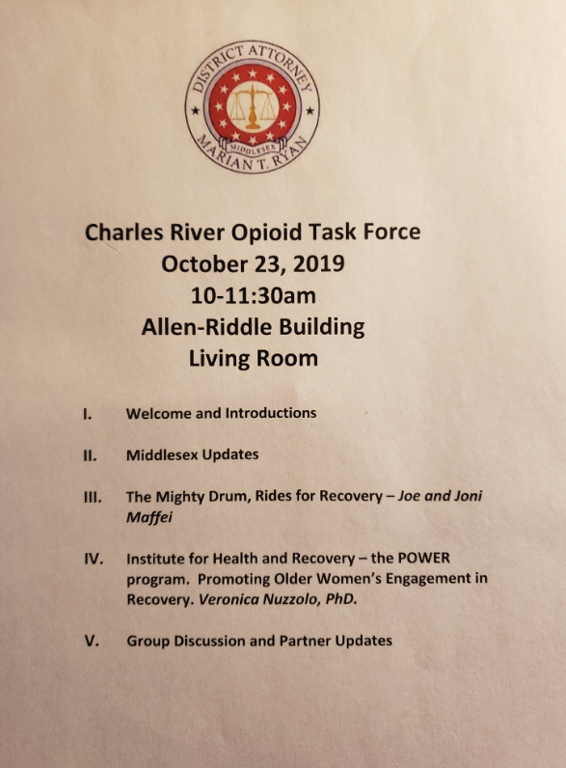

Project Attachments – Consumer Educational Materials

Talk to your Doc

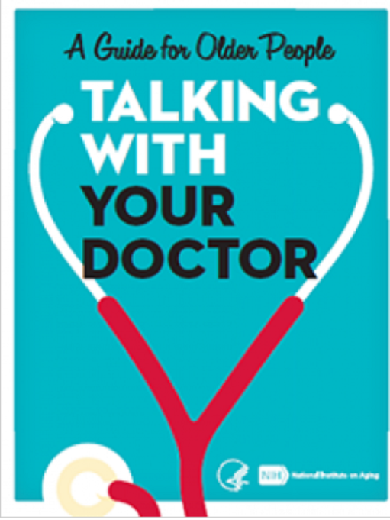

Older Adults and Alcohol
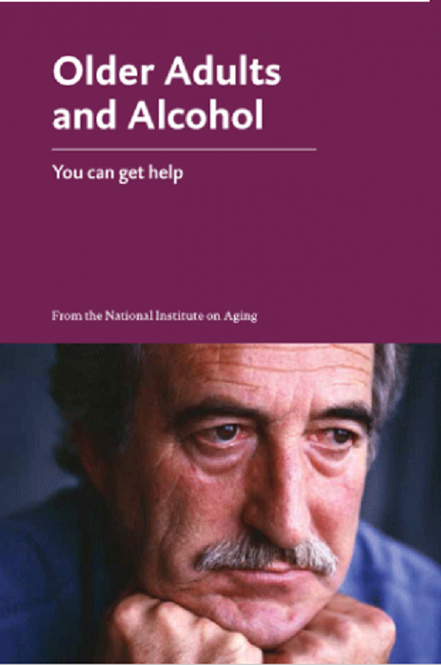

Safe Use of Medications
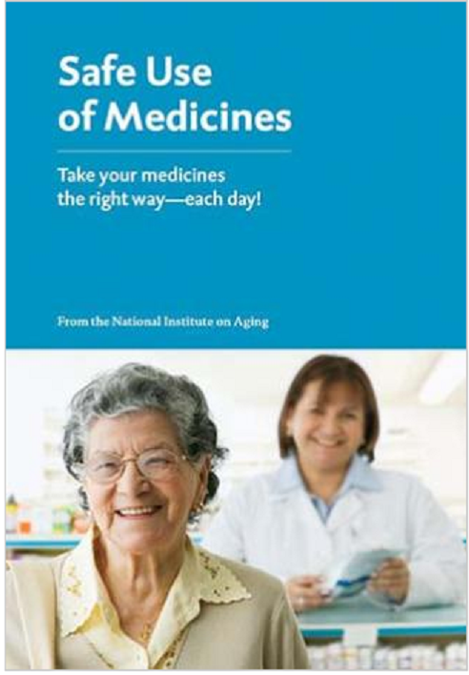

Exercise and Physical Activity
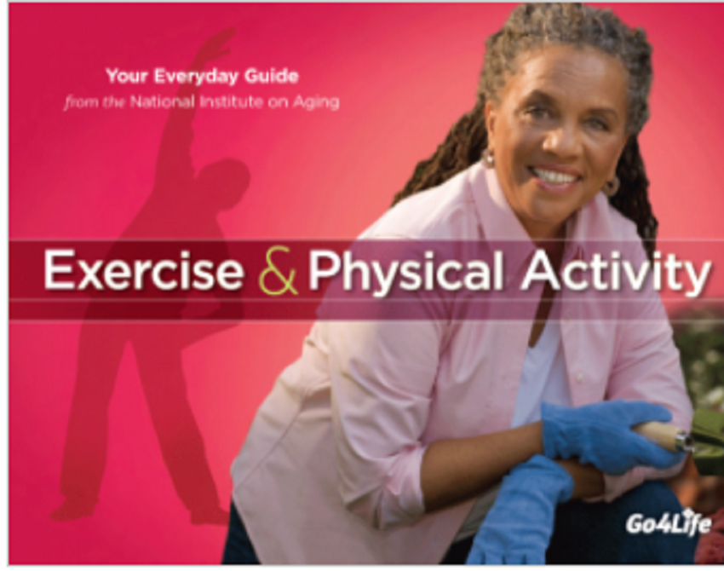

Workout to Go
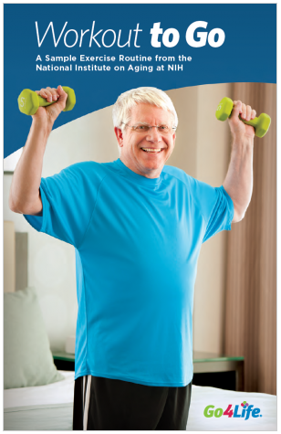

Healthy Eating – What’s on Your Plate


Project Attachments – Agency/Staff Workshop Educational Materials

Talking to Your Patients about Opioids
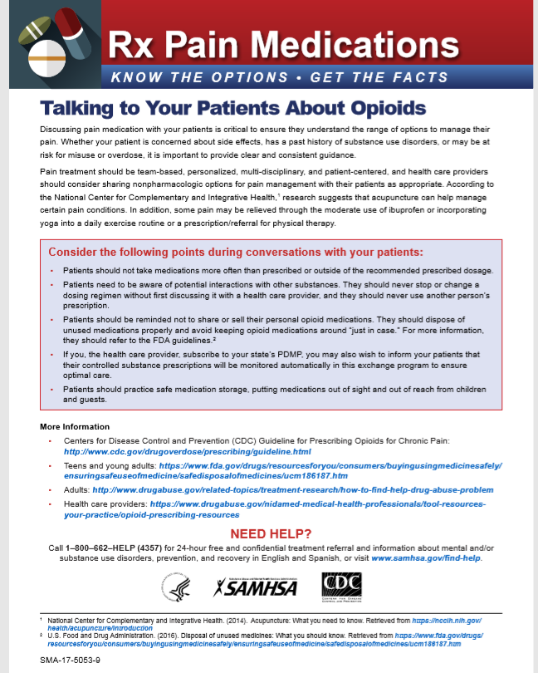

Talking with Your Older Patients
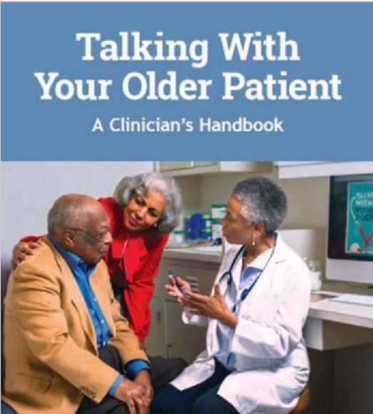

Language Matters 1
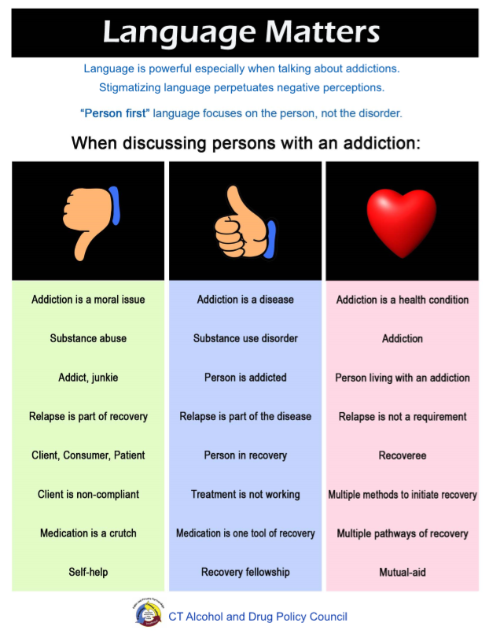

Language Matters 2
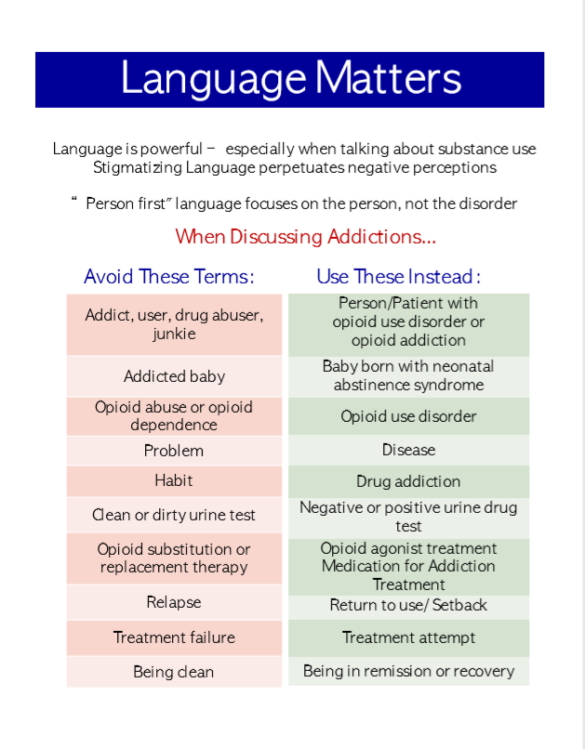

DSM V Opioid Use Disorder
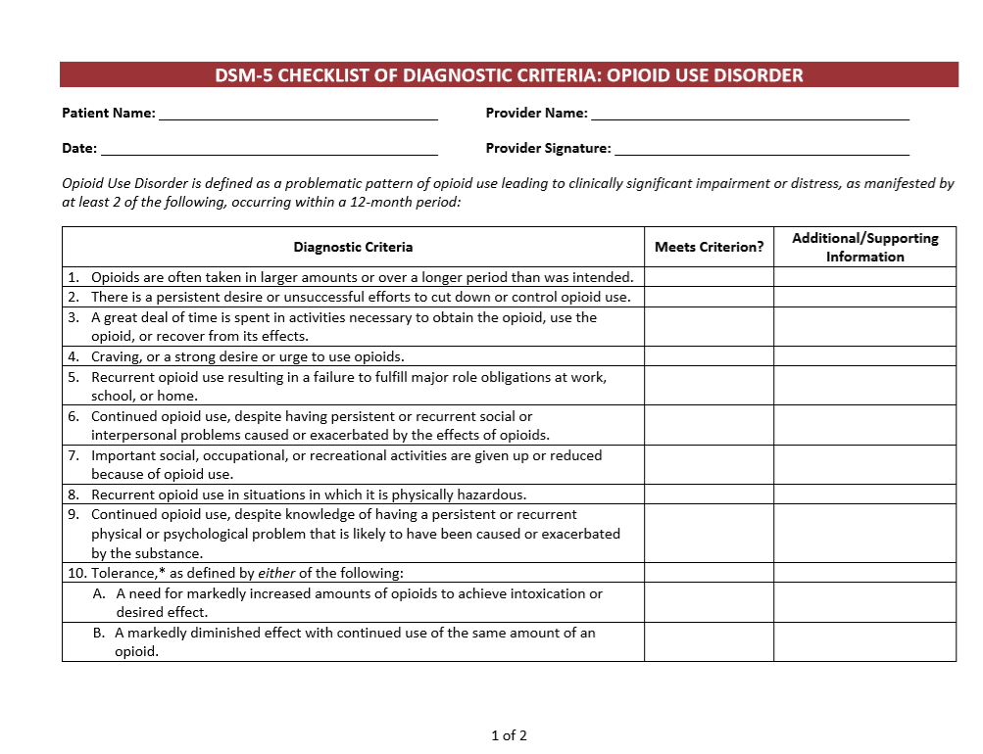
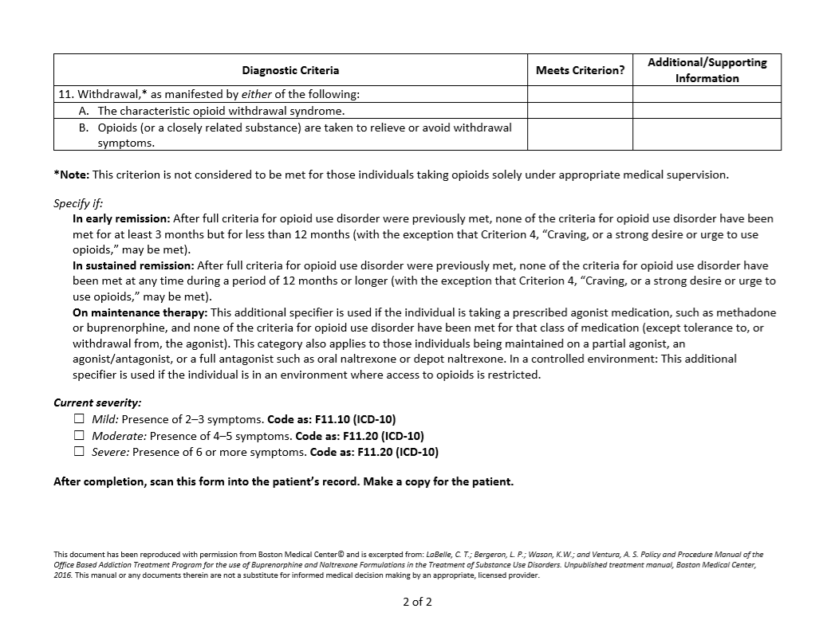

Signs and Symptoms of Potential Opioid Use
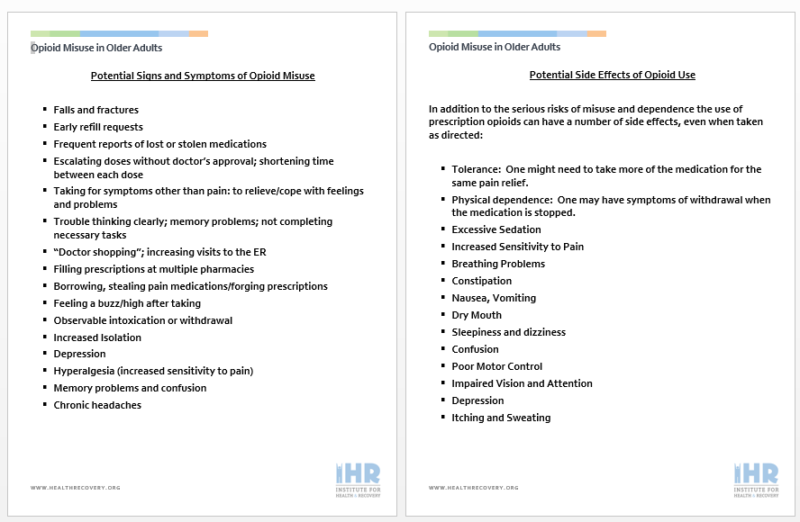

Commonly Used Terms
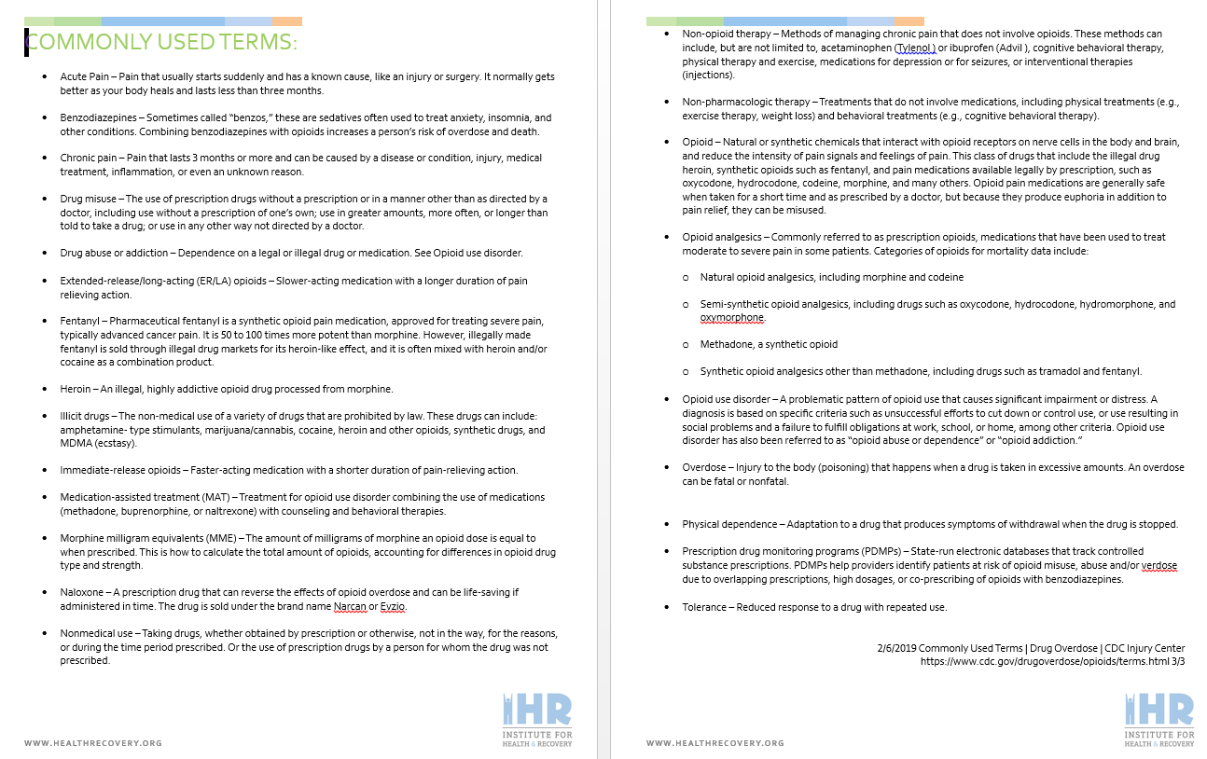

SBIRT Revised Screening Tool
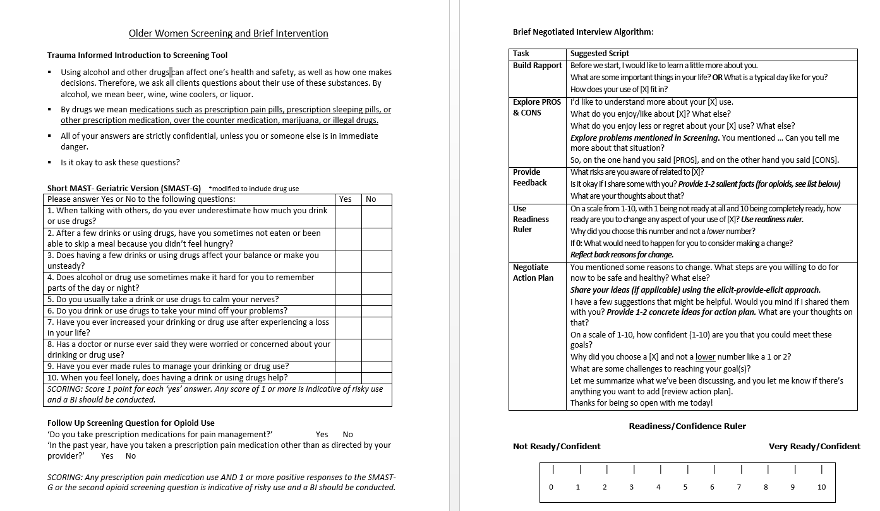

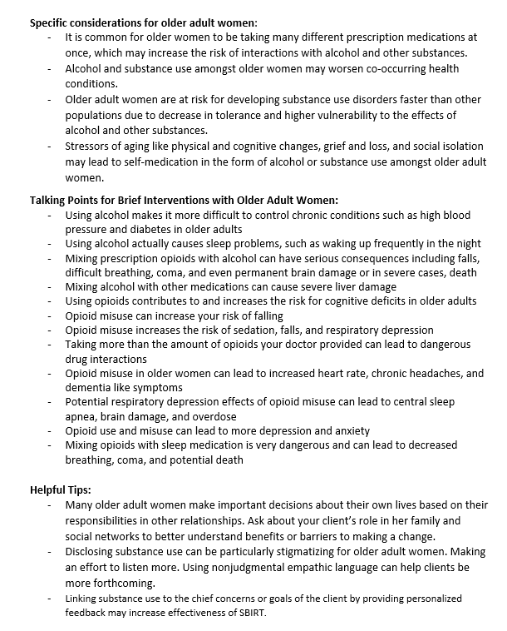

Training Evaluations

Opioid Training Evaluation
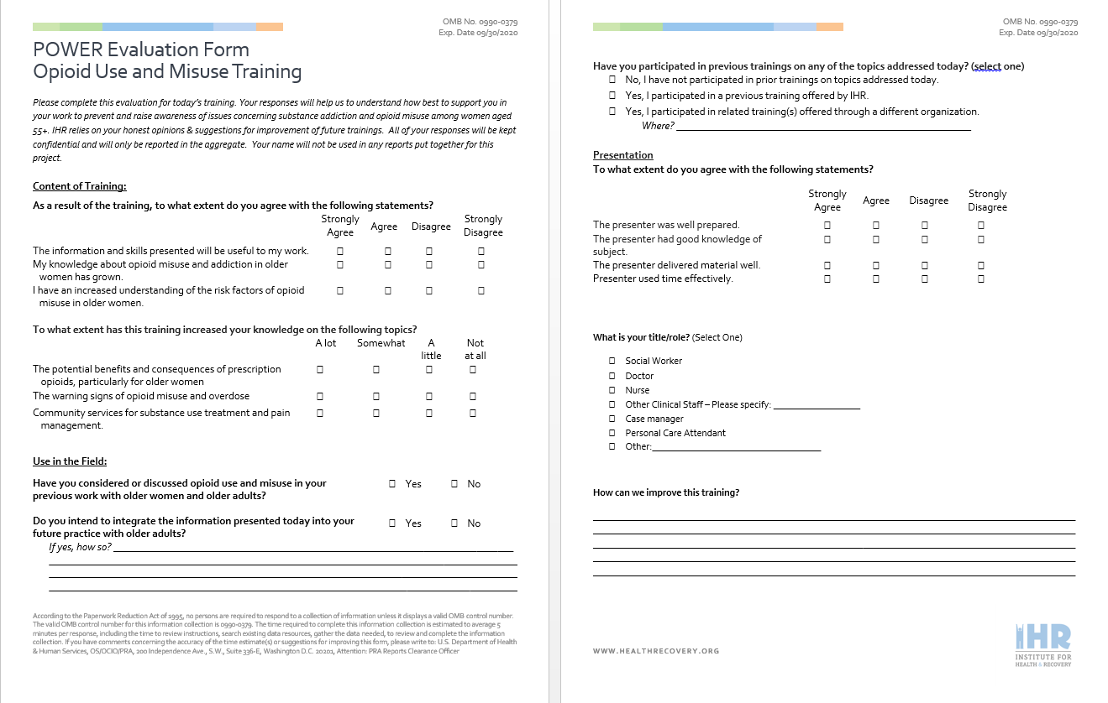
Trauma Informed Training Evaluation
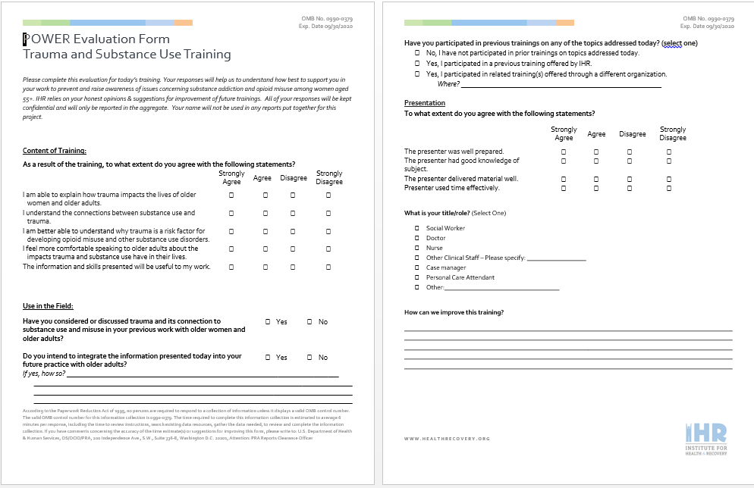

SBIRT Training Evaluation
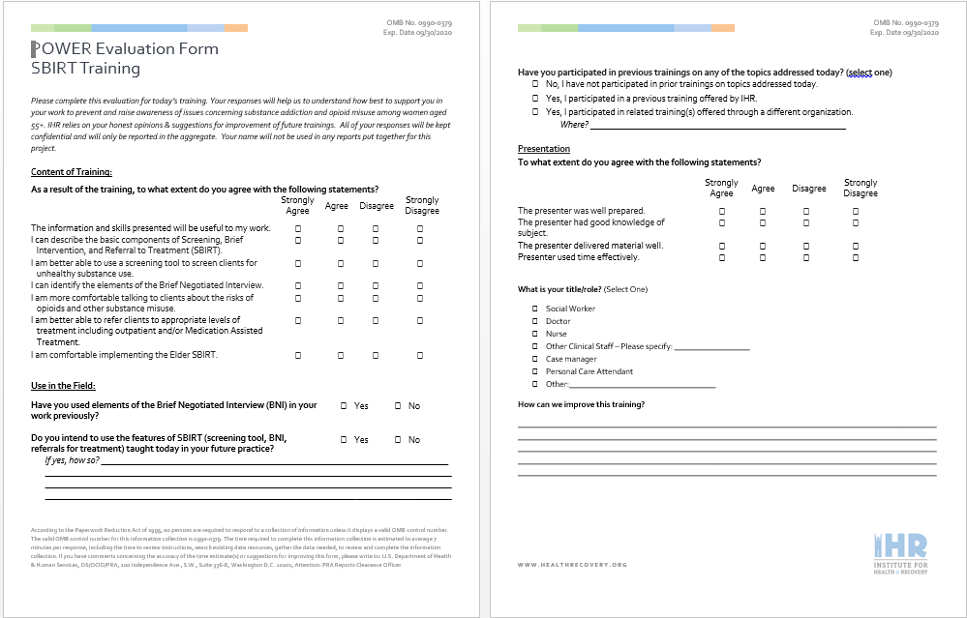

Motivational Interviewing Training Evaluation
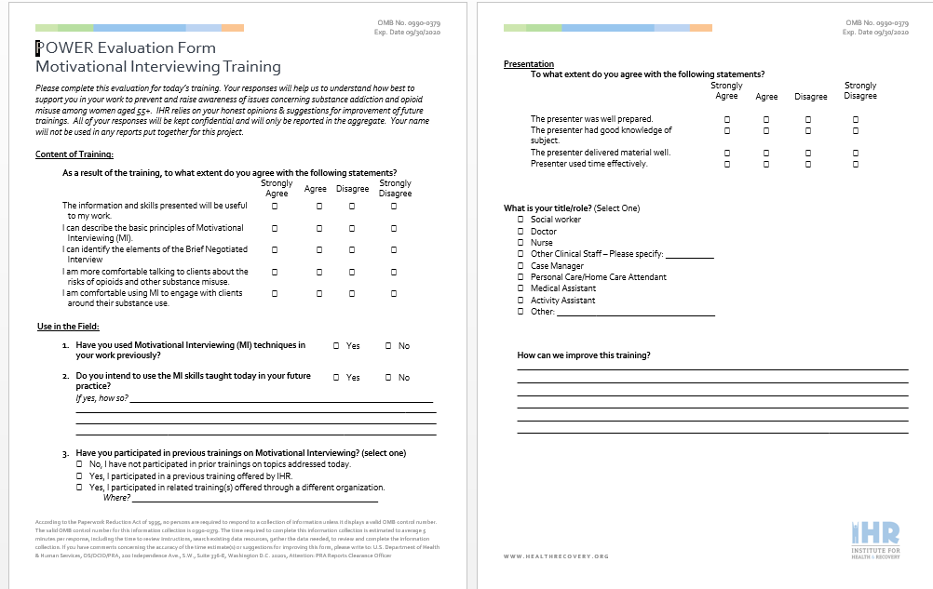

Opioid 101 Training Workshop – 3 Part Webinar Series

Double Click to Review Presentation
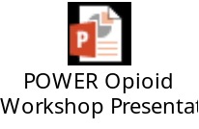
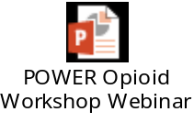

Change in functionality of IHR due to COVID-19

Email Notification 1
From: Norma Finkelstein
Sent: Sunday, June 28, 2020 7:19 PM
To: IHR Staff
Subject: Update
Importance: High

Dear Staff: Sorry to be late in getting this email to you all. As most of you know, the governor has asked everyone who can work remotely to continue to do so. Therefore, we will continue our remote work until at least September, and for many probably longer. We are encouraged by the MA Senate’s bill to continue to pay for telephonic and telehealth services for the foreseeable future (not passed yet I believe). While our offices remain mostly closed, there are staff who have requested to work in an office for a day or two each week and other staff who have needed to come into our offices, especially Cambridge, to retrieve files, pick up new computers and other equipment, collect mail (thank you Angela!), etc. Before anyone can come into any of our offices you must first talk to your supervisor and the supervisor or you have to alert Carol Blair who is coordinating visits to all IHR offices. This is so we can prevent overlap of multiple staff at any one time in any of our offices. We will be opening our Boston and Springfield office in August for one or two ATR staff a few days a week to hand out bus and T passes, etc. Of course, no clients will be admitted without an appointment (no walk-ins) and only one client at a time. We are busy developing protocols for all IHR offices, including resumption of some services on site. We have been purchasing the necessary PPE and other protective equipment, including over 11,000 masks (in addition to cloth masks donated), gloves and various sizes of hand sanitizer. We will make sure all offices have this equipment. We are researching various alternative office cleaning and sanitizing services. We are adhering of course to all guidelines developed by the Governor and his task force, the Department of Public Health and other state officials re: a gradual re-opening of offices.
Staff who need to make necessary outside visits to clients, including driving by and dropping off gift cards, etc. must talk with their supervisor and clinical supervisors should confer with Vanessa and/ or myself or Katharine before this is permitted to occur. There are protocols in place for this which all supervisors have, including masks, social distancing, etc.
In many ways re-opening our offices is much more complicated then closing them initially; we are committed to ensuring all staff and clients stay safe.
I know how difficult this time is for everyone since we are dealing with a pandemic and combatting racism and police violence at the same time. I am reminded of the success we have had at different periods of time, from the Civil and Women’s Rights Movements, to the LGBTQ movements for legal rights to marry and in the workforce (Happy Pride Day). As a person who was deeply involved in the civil rights, women’s rights and anti-Vietnam war protests, I am deeply moved and impressed to witness so many of you actively involved in building a strong anti-racism and social justice movement. IHR’s leadership is committed to these efforts with you and within our organization.
I look forward to speaking with you at our all staff meeting on July 10th. Thank you for all that you do

Norma
Norma Finkelstein, Ph.D.
Executive Director
Institute for Health and Recovery
349 Broadway, Cambridge, MA 02139
P: 617-661-3991 / F: 617-661-7277
http://www.healthrecovery.org/

Email Notification 2

From: Norma Finkelstein
Sent: Monday, May 18, 2020 4:17 PM
To: IHR Staff
Subject: governor's message
Importance: High

Dear Staff: As you can see from the governor’s message today, health and human services programs are not included in this Phase One of re-opening. Therefore, IHR’s offices will remain closed until July 1. This DOES NOT mean we will begin opening our offices on July 1. We are taking a month at a time for now to see what funding agencies begin to advise, what the data is around safety and opening of offices. Since schools and day care remain closed, it is unlikely we will open offices while these are closed. In the meantime we are ordering PPE and discussing sanitizing of offices, social distancing and other measures to keep staff and clients safe when we do re-open We are hopeful the flexibility we have been given from funders in terms of telehealth, will continue going forward for the near future.
We will certainly keep you posted as we learn more but rest assured when we do re-open it will be done with careful planning with protective measures for all in place.
Hope you are all staying healthy and finding ways to enjoy the beautiful spring (weather wise) we are having. Be well,

Norma Finkelstein, Ph.D.
Executive Director
Institute for Health and Recovery
349 Broadway, Cambridge, MA 02139
P: 617-661-3991 / F: 617-661-7277
http://www.healthrecovery.org/

Email Notification 3
From: Norma Finkelstein
Sent: Tuesday, March 31, 2020 1:22 PM
To: IHR Staff
Subject: new dates for opening
Importance: High

Dear Staff: I hope that you are all doing well during this extremely distressing time. I know that you are doing your usual best in taking care of clients, helping providers do their work with training and support and keeping in touch with and supporting each other. We will leave this time with new expertise in telemedicine, Zoom and other virtual ways to communicate. Thank you for being willing to try these and other new avenues as we negotiate some new information and technology almost every day. I wanted to make sure you all know that following our governor’s and the President’s guidelines, IHR’s physical offices will remain closed until Monday, May 4th. We will re-evaluate that date as we get closer to that time. In the meantime, I hope you and your loved ones stay safe and well. Thanks for all you do to take care of others. Please also take care of yourselves.

Norma

Norma Finkelstein, Ph.D.
Executive Director
Institute for Health and Recovery
349 Broadway, Cambridge, MA 02139
P: 617-661-3991 / F: 617-661-7277
http://www.healthrecovery.org/

Email Notification 4

From: Katharine Thomas
Sent: Monday, March 16, 2020 2:40 PM
To: IHR Staff
Subject: IMPORTANT: Offices Closing
Importance: High

Dear IHR Staff,

As of the end of the day tomorrow, Tuesday, all IHR offices will physically close until further notice but at least until April 6, 2020. ALL IHR staff are expected to be working remotely as communicated to you through your individual supervisors. This includes staff who see clients, who will all be delivering services via phone, FaceTime, and Zoom.

Today and tomorrow is your chance to come to the offices if needed and pick up any supplies you may need while working at home. Your supervisor will communicate directly with you, but as noted, staff should use Sign-Out Board to record their phone or email and note that they are working remotely. Other expectations will include checking your voicemail , and returning calls. Both the Boston and Cambridge offices will have recorded messages indicating that though we have physically closed offices for the safety of all, staff continue to work. In Cambridge, we will put an arrangement in place for Angela to continue to answer forwarded phones and check messages.

It is of critical importance that staff constantly check their email and phones for important updates as they occur. We are responding to an unprecedented situation that is changing quickly. Please feel free to be in touch with me or Norma as well as your supervisor with any questions. Please stay healthy and thank you for your flexibility and responsiveness!

Katharine Thomas
Assistant Director

Institute for Health and Recovery (IHR)
349 Broadway
Cambridge, MA 02139
PH 617.661.3991, FAX 617.661.7277
E: katharinethomas@healthrecovery.org

